PHOTOGRAPHY BUSINESS MANAGEMENT SYSTEM
A Project Report

Submitted in partial fulfilment of the
Requirements for the award of the Degree of
BACHELOR OF SCIENCE (COMPUTER SCIENCE)
By
Mr.Dipesh Dilip Patne
Seat No: ( 510512598 )

Under the esteemed guidance of

Mrs. Manisha S. Mahadik
Project Guide


DEPARTMENT OF COMPUTER SCIENCE
DR. BABASAHEB AMBEDKAR COLLEGE OF ARTS, SCIENCE & COMMERCE
(Affiliated to University of Mumbai)
MAHAD-RAIGAD 402301 MAHARASHTRA

PROFORMA FOR THE APPROVAL PROJECT PROPOSAL

PRN/ERN No:( MU0341120240127683 ) Roll No: 436

1.Name of the Student
Dipesh Dilip Patne

2.Title of the Project
Photography Business Management System

3.Name of the Guide
Professor Manisha S. Mahadik

4.Teaching experience of the Guide _____________

5.Is this your first submission? Yes No

Signature of the Student Signature of the Guide

Date: ________________ Date: ________________

Signature of the Coordinator

Date: ________________

DR. BABASAHEB AMBEDKAR COLLEGE, MAHAD
(Affiliated to University of Mumbai)
MAHAD-MAHARASHTRA-402301

DEPARTMENT OF COMPUTER SCIENCE

CERTIFICATE

This is to certify that the project entitled, “Photography Business Management
System”, is bonafied work of Mr. Dipesh Dilip Patne bearing Seat. No: (
submitted in partial fulfilment of the requirements for the award of degree of
BACHELOR OF SCIENCE in COMPUTER SCIENCE from University of
Mumbai.

Internal Coordinator

External Examiner

Date: College Seal

Date: College seal

ABSTRACT

Small and mid-sized photography studios, such as wedding, portrait, event and product photographers, still run their business on phone contacts, WhatsApp chats, paper diaries and loosely maintained spreadsheets. This creates recurring problems: two clients are accidentally promised the same date, package prices quoted months ago are forgotten or disputed, advance and balance payments are tracked on scraps of paper, delivery deadlines for edited photos and albums slip without anyone noticing, and the loss of a phone or diary erases the studio's client and financial history. The Photography Business Management System is a full-stack web application that digitises this complete loop for a single operator, the Studio Owner, who runs the studio.
The system is implemented as a vanilla HTML5, CSS3 and JavaScript frontend of eleven pages served as static files, and a Node.js and Express.js REST API backed by MongoDB through the Mongoose ODM. The backend exposes thirty-two endpoints organised into seven route modules, covering authentication with JSON Web Tokens and bcrypt password hashing, client management with search and lifecycle rules, append-only package and pricing management, booking management with date-conflict detection, payment tracking, reporting and export. Every business number is computed on the server: when a booking is created, the applicable price is resolved from the package version in force and copied onto the booking, and the total, paid amount and balance are calculated by the server; the stored price is never recalculated, so historic bookings remain stable even when the studio revises its price list. All data is isolated per studio, which allows multiple independent studios to share one deployment.

ACKNOWLEDGMENT

I take this opportunity to express my sincere gratitude to all those who have contributed to the successful completion of this project. First and foremost, I am deeply thankful to my project guide [Professor Manisha S. Mahadik], Department of Computer Science, [DR.BABASAHEB AMBEDKAR COLLEGE MAHAD,RAIGAD], for the constant encouragement, valuable guidance and patient supervision extended to me at every stage of this work.

I am equally grateful to the Head of the Department of Computer Science and to all the faculty members for creating an environment that encourages practical learning and independent thinking. I sincerely thank the Principal and the management of [DR.BABASAHEB AMBEDKAR COLLEGE MAHAD,RAIGAD] for providing the facilities, the computer laboratory and the institutional support that made this work possible. I also thank the photographers and studio owners who shared their day-to-day workflow with me during requirement gathering. Finally, I express my heartfelt thanks to my family and friends for their understanding, patience and moral support.

Student Name: Dipesh Dilip Patne
Seat No:510512598

DECLARATION

I hereby declare that the project entitled "Photography Business Management System" submitted for the partial fulfillment of the requirements for the award of the degree of Bachelor of Science (Computer Science) is my original work carried out under the supervision of my project guide at the Department of Computer Science, [DR.BABASAHEB AMBEDKAR COLLEGE MAHAD,RAIGAD], during the academic year [2026-27].

This project has not been submitted to any other university or institution for the award of any other degree, diploma or certificate. All external libraries and tools used in this project have been acknowledged in the references section. The project source code is maintained in public GitHub repositories, and the live deployment can be accessed at the web address mentioned in the report.

Date: Name and Sign of Student
Dipesh Dilip Patne

1.INTRODUCTION

1.1 Background
Photography has grown from a hobby into a significant small-business sector. Wedding, pre-wedding, maternity, newborn, corporate event, fashion and product shoots are booked by individual studios, many of which are run by one owner with a small team of assistants and freelance editors. The business of such a studio is not only the creative work: it involves taking enquiries, quoting packages, confirming dates, collecting advances, assigning photographers, tracking the delivery of edited photos and albums, collecting the balance payment and issuing receipts.
In most small studios this workflow is held together by memory, phone contacts, chat messages and a diary. Dates are double-booked, quoted prices are disputed, the balance owed by a client is unclear, and the status of a pending album is known only to the person who last spoke to the client. As the number of bookings grows, especially in the wedding season, this informal method breaks down. A dedicated, simple and affordable software system can bring order to this workflow.

1.2 Objectives
The objectives of the Photography Business Management System are:
- To replace paper diaries and ad-hoc spreadsheets with a secure web application that records clients, bookings and payments in a central database.
- To maintain a price list of photography packages whose history is preserved, so that every booking keeps the price that was actually agreed.
- To detect date and time conflicts when a booking is created, preventing double-booking.
- To track every booking through its life cycle, from enquiry to confirmation, shoot, delivery and closure.
- To record advance, instalment and final payments and compute the outstanding balance automatically on the server.
- To generate daily, monthly, date-range and client statement reports and to export them as PDF and Excel documents, and to produce printable invoices.
- To isolate the data of each studio so that several independent studios can share one deployment.
- To deliver a responsive interface usable on a desktop in the studio and on a phone at a shoot location.

1.3 Purpose and Scope

1.3.1 Purpose
The purpose of the system is to give a Studio Owner a single, reliable place to manage the commercial side of a photography business. It is intended to reduce arithmetic and scheduling mistakes, make payments transparent to both the studio and its clients, and give the owner a clear picture of revenue and pending dues at any time.

1.3.2 Scope
The system covers the following areas.
- In scope: registration of a studio and login of the Studio Owner; client records; package and price management; booking creation, editing, status tracking and cancellation; payment recording; dashboard statistics; reports and exports; invoice generation; profile management.
- Out of scope for the current version: online payment gateways, a client-facing portal, photo upload and gallery delivery, staff payroll, inventory of cameras and equipment, and mobile native applications. Some of these are proposed in Chapter 6 as future work.
The system is designed for one operator per studio. Multiple studios are supported through organization-level data isolation, but each studio has a single login role.

1.4 Feasibility Study

1.4.1 Technical Feasibility
The system uses widely adopted, open-source technologies: HTML, CSS and JavaScript for the frontend, Node.js and Express.js for the API, and MongoDB for storage. These technologies are well documented, run on ordinary hardware, and offer free hosting tiers suitable for a small deployment. The development team has working knowledge of all of them, so the project is technically feasible.

1.4.2 Economic Feasibility
All software components are free and open source. Hosting uses the free tiers of Netlify (frontend), Render (API) and MongoDB Atlas (database). The only recurring cost for a production studio would be an optional custom domain or a paid hosting tier if usage grows. Compared with commercial studio-management products that charge monthly subscriptions, the proposed system is economically feasible for small studios.

1.4.3 Operational Feasibility
The interface follows the vocabulary photographers already use: clients, packages, bookings, advance and balance. Screens are limited in number, forms are short, and the dashboard shows the information an owner needs first thing in the morning, namely today's shoots and pending dues. Because the system runs in a browser, no installation or training beyond a short walkthrough is required, so it is operationally feasible.

1.5 Motivation
The motivation for this project came from observing local photography studios during wedding season. Owners spent evenings reconciling chat messages and notebooks to find out who had paid what, which shoots were next, and which albums were overdue. Missed dates and payment disputes damaged client relationships and cost money. Existing commercial tools were either too expensive, too complex, or not designed around the way small Indian studios take an advance and collect the balance after delivery. This project aims to fill that gap with a focused, easy-to-use system.

TABLE OF CONTENTS
Sr. No. | Chapter / Section Name
1 | Certificate
2 | Acknowledgement
3 | Abstract
4 | Table of Contents
5 | List of Figures
6 | List of Tables
 | CHAPTER 1: INTRODUCTION
1.1 | Introduction to the Project
1.2 | Problem Statement
1.3 | Objectives of the Project
1.4 | Scope of the Project
1.5 | Existing System
1.6 | Proposed System
 | CHAPTER 2: PROJECT PLANNING AND ANALYSIS
2.1 | Project Planning
2.2 | Feasibility Study
2.3 | Hardware and Software Requirements
2.4 | Development Methodology
2.5 | Gantt Chart (Fig. 2.1)
 | CHAPTER 3: SYSTEM DESIGN
3.1 | System Architecture
3.2 | Three-Tier Architecture (Fig. 3.1)
3.3 | Deployment Architecture (Fig. 3.2)
3.4 | E-R Diagram – Conceptual Model (Fig. 3.3)
3.5 | E-R Diagram – Logical Model (Fig. 3.4)
3.6 | Data Flow Diagram – Level 0 (Fig. 3.5)
3.7 | Data Flow Diagram – Level 1 (Fig. 3.6)
3.8 | Data Flow Diagram – Level 2 (Fig. 3.7)
 | CHAPTER 4: IMPLEMENTATION AND TESTING
4.1 | Tools and Technologies Used
4.2 | Frontend Implementation
4.3 | Home Page and About Section
4.4 | Photography Gallery
4.5 | Services Section
4.6 | Contact Form and Enquiry Process
4.7 | System Testing
4.8 | Test Cases and Results
 | CHAPTER 5: RESULT AND CONCLUSION
5.1 | Result
5.2 | Conclusion
5.3 | Future Scope
5.4 | References / Bibliography

⋮⋮⋮⋮

CHAPTER 1: INTRODUCTION

1.1 Background
Photography has grown from a hobby into a significant small-business sector. Wedding, pre-wedding, maternity, newborn, corporate event, fashion and product shoots are booked by individual studios, many of which are run by one owner with a small team of assistants and freelance editors. The business of such a studio is not only the creative work: it involves taking enquiries, quoting packages, confirming dates, collecting advances, assigning photographers, tracking the delivery of edited photos and albums, collecting the balance payment and issuing receipts.
In most small studios this workflow is held together by memory, phone contacts, chat messages and a diary. Dates are double-booked, quoted prices are disputed, the balance owed by a client is unclear, and the status of a pending album is known only to the person who last spoke to the client. As the number of bookings grows, especially in the wedding season, this informal method breaks down. A dedicated, simple and affordable software system can bring order to this workflow.

1.2 Objectives
The objectives of the Photography Business Management System are:
- To replace paper diaries and ad-hoc spreadsheets with a secure web application that records clients, bookings and payments in a central database.
- To maintain a price list of photography packages whose history is preserved, so that every booking keeps the price that was actually agreed.
- To detect date and time conflicts when a booking is created, preventing double-booking.
- To track every booking through its life cycle, from enquiry to confirmation, shoot, delivery and closure.
- To record advance, instalment and final payments and compute the outstanding balance automatically on the server.
- To generate daily, monthly, date-range and client statement reports and to export them as PDF and Excel documents, and to produce printable invoices.
- To isolate the data of each studio so that several independent studios can share one deployment.
- To deliver a responsive interface usable on a desktop in the studio and on a phone at a shoot location.

1.3 Purpose and Scope

1.3.1 Purpose
The purpose of the system is to give a Studio Owner a single, reliable place to manage the commercial side of a photography business. It is intended to reduce arithmetic and scheduling mistakes, make payments transparent to both the studio and its clients, and give the owner a clear picture of revenue and pending dues at any time.

1.3.2 Scope
The system covers the following areas.
- In scope: registration of a studio and login of the Studio Owner; client records; package and price management; booking creation, editing, status tracking and cancellation; payment recording; dashboard statistics; reports and exports; invoice generation; profile management.
- Out of scope for the current version: online payment gateways, a client-facing portal, photo upload and gallery delivery, staff payroll, inventory of cameras and equipment, and mobile native applications. Some of these are proposed in Chapter 6 as future work.
The system is designed for one operator per studio. Multiple studios are supported through organization-level data isolation, but each studio has a single login role.

1.4 Feasibility Study

1.4.1 Technical Feasibility
The system uses widely adopted, open-source technologies: HTML, CSS and JavaScript for the frontend, Node.js and Express.js for the API, and MongoDB for storage. These technologies are well documented, run on ordinary hardware, and offer free hosting tiers suitable for a small deployment. The development team has working knowledge of all of them, so the project is technically feasible.

1.4.2 Economic Feasibility
All software components are free and open source. Hosting uses the free tiers of Netlify (frontend), Render (API) and MongoDB Atlas (database). The only recurring cost for a production studio would be an optional custom domain or a paid hosting tier if usage grows. Compared with commercial studio-management products that charge monthly subscriptions, the proposed system is economically feasible for small studios.

1.4.3 Operational Feasibility
The interface follows the vocabulary photographers already use: clients, packages, bookings, advance and balance. Screens are limited in number, forms are short, and the dashboard shows the information an owner needs first thing in the morning, namely today's shoots and pending dues. Because the system runs in a browser, no installation or training beyond a short walkthrough is required, so it is operationally feasible.

1.5 Motivation
The motivation for this project came from observing local photography studios during wedding season. Owners spent evenings reconciling chat messages and notebooks to find out who had paid what, which shoots were next, and which albums were overdue. Missed dates and payment disputes damaged client relationships and cost money. Existing commercial tools were either too expensive, too complex, or not designed around the way small Indian studios take an advance and collect the balance after delivery. This project aims to fill that gap with a focused, easy-to-use system.

Gantt Chart :
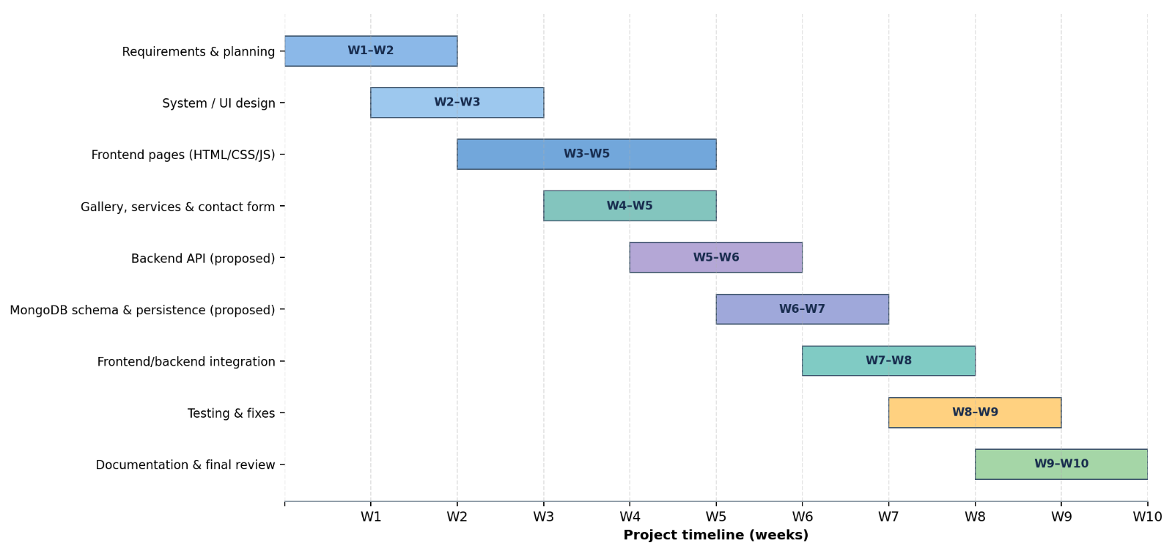

CHAPTER 2: SYSTEM ANALYSIS
Technical and user documentation for the one-page photography and videography portfolio website. Prepared from the project files index.html, style.css, script.js and readme.md.
1. Project Overview
Dipesh Patne Films is a one-page portfolio website for a photographer and videographer who shoots weddings, pre-weddings, portraits and events. The site shows his work, explains his services and lets a visitor send an enquiry. When a visitor submits the enquiry form, the enquiry is saved by a Django backend and WhatsApp opens with a ready-made message to the business number.
Item | Detail
Site name | Dipesh Patne | Films
Page title | Dipesh Patne | Photography & Videography
Type | Single-page static website with one backend API call
Frontend | Plain HTML5, CSS3 and JavaScript (no framework, no build step)
Backend | Django (separate project, photography_business_backend)
Fonts | DM Sans (body) and Playfair Display (headings), loaded from Google Fonts
Theme | Dark editorial theme with a warm gold accent
Main goal | Present the work and convert visitors into enquiries
1.1 Key Features
- Animated preloader and staggered hero entrance.
- Scroll-reveal animation on every section, using IntersectionObserver.
- Animated counters in the About section (shoots done, years of craft, happy clients).
- Photo gallery with a full-screen lightbox: previous and next buttons, keyboard arrows, Escape key and touch swipe.
- Sticky header that hides while scrolling down and returns when scrolling up, with active-section highlighting.
- Mobile menu and a back-to-top button.
- Contact form with validation, loading state and toast notifications instead of browser alert popups.
- Offline fallback: if the backend cannot be reached, WhatsApp still opens so no enquiry is lost.
- Respect for the visitor's reduced-motion setting.

2. Folder Structure
project-folder/
index.html the whole page (markup and content)
style.css theme, layout, animations, responsive rules (about 920 lines)
script.js all behaviour: UI effects and the enquiry form
readme.md short project notes
images/ portfolio photographs
Dipesh.JPG, Pink.JPG, Butterfly.jpg, photo3.jpg, photo4.jpg,
photo1.jpg, Dragonfly.JPG, Sparrow.JPG
../photography_business_backend/ Django backend (separate folder)
File | Responsibility
index.html | Structure and text of every section, SVG icons, the favicon (an inline SVG camera in the accent colour) and the lightbox and toast containers.
style.css | Design tokens, layout, hover states, animations, the 800 px and 480 px breakpoints and the reduced-motion rule.
script.js | Preloader, menu, header state, reveal animation, counters, lightbox, toast, footer year and the enquiry form.
images/ | Photographs used by the About and Gallery sections.
3. Getting Started

CHAPTER 3: SYSTEM DESIGN

3.1 Run the Frontend
There is nothing to install. Use either option:
- Open index.html directly in a browser.
- Or serve the folder with any static server, for example the VS Code Live Server extension, which usually runs at http://127.0.0.1:5500.
3.2 Run the Backend
The form posts to the Django API at http://127.0.0.1:8000/api. Start the Django backend first, following ../photography_business_backend/README.md. Typical commands for a Django project are shown below. Confirm them against your backend's own README.
cd photography_business_backend
python -m venv venv
venv\Scripts\activate # Windows (use source venv/bin/activate on macOS or Linux)
pip install -r requirements.txt
python manage.py migrate
python manage.py runserver # serves http://127.0.0.1:8000
The Django server must also allow the frontend's origin through CORS (for example http://127.0.0.1:5500), otherwise the browser will block the request and the site will fall back to WhatsApp only.
3.3 Configuration Constants
Two constants at the top of script.js control the integrations.
Constant | Current value | Change it to
API_BASE | http://127.0.0.1:8000/api | The live backend address, for example https://your-backend.example.com/api
WHATSAPP_NUMBER | 918468811790 | The business WhatsApp number, in international format without + or spaces
4. Page Structure
The page is a single scroll with six content areas, a footer and four overlay elements. The navigation links jump to the section ids listed below.
Order | Section | Element and id | Content
0 | Preloader | #preloader | Camera icon, DIPESH PATNE | FILMS and an animated loading bar. Hidden after the page loads.
1 | Header | #siteHeader | Logo and the menu (Home, About, Gallery, Services, Contact). #menuBtn opens the menu on small screens.
2 | Hero | #home | Eyebrow, headline "Capturing Beautiful Moments", tagline, View My Work button and a Scroll to Explore hint.
3 | About | #about | Portrait, introduction, three animated statistics and a Let's Work Together button.
4 | Gallery | #gallery | Four photographs as buttons that open the lightbox.
5 | Services | #services | Three cards: Photography, Videography, Weddings.
6 | Video | (no id) | Watch the Moments heading, Book a Shoot button and a placeholder box labelled VIDEO / REEL.
7 | Contact | #contact | A contact card (WhatsApp, Email, Instagram) beside the enquiry form.
8 | Footer | .footer | Name, tagline, Instagram and WhatsApp links and a copyright line with the current year.
Overlay | Back to top | #toTop | Round button shown after scrolling about 700 px.
Overlay | Toast | #toast | Short status message at the bottom of the screen.
Overlay | Lightbox | #lightbox | Full-screen image viewer with close, previous and next buttons.

CHAPTER 4 : IMPLEMENTATION AND TESTING

4.1 About Statistics
The three counters read their target from the data-count attribute.
Label | Target (data-count) | Suffix
Shoots Done | 150 | +
Years of Craft | 6 | +
Happy Clients | 98 | %
4.2 Gallery
Each gallery item is a button.gallery-item containing a thumbnail img and a hover overlay icon. The attribute data-full holds the path of the large image shown in the lightbox, and the thumbnail path is in the img tag.
Item | Lightbox image (data-full) | Thumbnail (img src)
1 | images/Pink.JPG | \images\Flower1.jpeg (see Known Issues)
2 | images/Butterfly.jpg | images/Butterfly.jpg
3 | images/photo3.jpg | images/photo3.jpg
4 | images/photo4.jpg | images/photo4.jpg
4.3 Enquiry Form Fields
Field | Control | Options or hint
name | Text input | Your Name
phone | Tel input | Phone / WhatsApp
service | Select | Wedding Photography, Wedding Videography, Pre-Wedding, Portrait Photography, Event Photography, Other
message | Textarea (5 rows) | Tell me about your event...
The form uses novalidate, so validation is done by script.js and not by the browser's built-in bubbles

4.4 Design System (style.css)
1. Design Tokens
Colours and sizes are defined once in :root and reused everywhere.
Variable | Value | Use
--bg | #0d0d0d | Page background
--surface | #151515 | Cards and panels
--text | #f4f1eb | Main text
--muted | #aaa49b | Secondary text
--line | #292929 | Borders and dividers
--accent | #d8c29b | Gold accent, buttons and highlights
--white | #fff | Pure white
--max | 1180px | Maximum content width
--ease | cubic-bezier(.22,.61,.36,1) | Shared easing curve for animations
To re-theme the site, change these variables; most of the page follows automatically.
2. Typography
Body text uses DM Sans (weights 400, 500, 700). Headings and statistics use Playfair Display (weights 500 and 600, with italics). Both are loaded with one @import at the top of style.css, and each has a fallback (Arial, Georgia or a generic serif).
3. Stylesheet Sections
The file is organised in labelled blocks in this order: Preloader, Header, Hero, Sections and reveal animations, About (with stats), Gallery, Services, Video section, Contact, Footer, Toast, Back to top, Lightbox, shared keyframes, Responsive and Accessibility.
4. Animations
Keyframes | Used for
Loading | Preloader progress bar
Pulse | Preloader icon
heroZoom | Slow zoom of the hero background
Shine | Light sweep effect
heroFadeIn | Staggered entrance of hero text (delay set by the --d custom property)
Bob | Bouncing scroll arrow
Ripple | Pulse around the video play button
Shake | Invalid form field feedback
Spin | Loading spinner on the submit button
zoomIn | Lightbox image entrance
fadeUp | Reveal on scroll and the mobile menu
The inline style --d:.25s on many elements sets an animation delay, which creates the staggered entrance.
5. Responsive Behaviour
Breakpoint | Changes
800 px and below | The menu button appears and the menu becomes a full-width dropdown. About, video and contact layouts become one column. Services and gallery become one column. Section padding is reduced and the video box is 300 px tall. Lightbox arrows become 44 px.
480 px and below | Tighter side margins (28 px), smaller hero letter-spacing, statistics wrap and the back-to-top button moves closer to the corner.
Reduced motion | When the visitor's system asks for reduced motion, animations and transitions are shortened to almost zero, smooth scrolling is turned off and the reveal and hero elements are shown immediately.

6. JavaScript Reference (script.js)
6.1 Feature Map
Feature | Elements used | Behaviour
Preloader | #preloader, class done | Hidden 450 ms after the window load event. A safety timer hides it after 3.5 seconds at most, so a visitor is never stuck.
Mobile menu | #menuBtn, #menu, class open | Toggles the menu, switches the button between the menu symbol and a close symbol, and updates aria-expanded and aria-label. Clicking a menu link closes the menu.
Header state | #siteHeader, classes scrolled, hidden-up | Adds scrolled after 40 px. Hides the header when scrolling down past 300 px and shows it again when scrolling up.
Active link | .menu a | Highlights the menu link whose section is currently in view (section top minus 140 px).
Back to top | #toTop, class show | Visible after 700 px. Click scrolls smoothly to the top.
Reveal on scroll | .reveal, class visible | IntersectionObserver with threshold 0.16 and a 40 px bottom margin. Each element is revealed once. Browsers without the API show everything immediately.
Counters | .stat-number, data-count | Counts from 0 to the target over 1.6 seconds with an ease-out cubic curve, started when 60 percent of the number is visible.
Lightbox | #lightbox, .gallery-item | Opens on click, supports previous and next with wrap-around, Escape to close, left and right arrow keys, click on the dark background and swipe of more than 46 px. The page does not scroll while it is open.
Footer year | #year | Writes the current year into the copyright line.
Toast | #toast, #toastMsg, class show | Shows a message for 4.2 seconds, or a custom duration. A new message resets the timer.
Enquiry form | #contactForm, #submitBtn | Validates, posts to the API, then opens WhatsApp. Described in section 7.
6.2 Main Functions
Function | Purpose
onScroll() | Updates header classes, back-to-top visibility and the active menu link on every scroll.
animateCounter(el) | Animates one statistic using requestAnimationFrame.
showPhoto(index) | Shows the photo at index in the lightbox using modulo arithmetic so the gallery loops.
openLightbox(index) / closeLightbox() | Open and close the viewer, set aria-hidden and lock or unlock page scroll.
showToast(message, duration) | Displays a notification.
markInvalid(el, invalid) | Adds or removes the invalid class on a form control.

7. Enquiry Form and Backend API
7.1 Submission Flow
- The visitor presses Send Enquiry.
- script.js reads the four fields and trims them.
- If any field is empty, it is marked invalid, a toast asks the visitor to fill every field, and nothing is sent.
- Otherwise the submit button shows its loading state and the script sends the enquiry to the API.
- If the server answers successfully, a thank-you toast is shown and the form is cleared. If it fails or cannot be reached, a toast explains that WhatsApp will open anyway and the form is kept.
- In both cases WhatsApp opens in a new tab with a prefilled message.
7.2 API Request
POST {API_BASE}/enquiries/
Content-Type: application/json
{
"name": "Asha Patil",
"phone": "9876543210",
"service": "Wedding Photography",
"message": "Wedding on 14 December in Pune, two days of coverage."
}
The script treats any successful HTTP status (the response.ok check) as saved. The exact success code and response body depend on your Django view, so add them here once confirmed, for example 201 Created with the saved record.
7.3 WhatsApp Message
The message opened at https://wa.me/918468811790 has this form:
Hello Dipesh, I would like to make an enquiry.
Name: ...
Phone: ...
Service: ...
Message: ...
The text is URL-encoded with encodeURIComponent, so line breaks and special characters arrive correctly.
7.4 Backend Details to Confirm
The backend was not part of the files used for this document. Add these details from the photography_business_backend project:
- Python and Django versions, and the packages in requirements.txt (for example Django REST Framework and django-cors-headers, if used).
- The Enquiry model fields (the form sends name, phone, service and message; Django usually adds an id and a creation time).
- The route, view and serializer names, and the success and error responses.
- How to create an admin user and view enquiries in the Django admin.
- Allowed hosts, CORS origins and the database used in production.
8. How to Update the Content
Task | Where | What to do
Change the WhatsApp number | script.js, index.html | Edit WHATSAPP_NUMBER, and the two https://wa.me/... links in the contact card and footer.
Fix or change the email | index.html, contact card | Edit the mailto: address.
Change the Instagram link | index.html, contact card and footer | Edit both href values so they point to the same profile.
Change the statistics | index.html, About section | Edit the data-count numbers and the suffix text.
Change the headline or copy | index.html, Hero and About sections | Edit the text. Keep the reveal and hero-fade classes so the animation keeps working.
Add a photo to the gallery | index.html, Gallery section | Copy one button.gallery-item block, change data-full, the img src, the alt text and aria-label, and increase the --d delay. The lightbox picks it up automatically.
Replace the video placeholder | index.html, .video-box | Replace the box content with a video or an embedded player, and adjust the .video-box styles.
Add a service option | index.html, form select | Add an option. The value is sent as the service field.
Change colours | style.css, :root | Edit the variables listed in section 5.1.
Change animation timing | script.js and style.css | Counter length is duration in animateCounter; preloader time is in the setTimeout calls; the --d values set the delays.

9. Accessibility and Performance
9.1 Accessibility
- The language is declared (lang="en") and the viewport meta tag is set.
- Buttons have aria-label text, the menu button updates aria-expanded, and decorative icons use aria-hidden.
- The toast uses role="status" with aria-live="polite" so screen readers announce it.
- The lightbox is controllable with the keyboard (Escape and arrow keys).
- Images have descriptive alt text.
- Reduced-motion preferences are respected.
9.2 Performance
- No framework, no build step and a single script and stylesheet.
- Gallery thumbnails use loading="lazy".
- Scroll listeners are passive, and reveal and counters use IntersectionObserver instead of scroll polling.
- The only external request at load time is Google Fonts. Consider compressing the photographs (for example to WebP and under about 300 KB each) before deployment.
10. Deployment Checklist
- Deploy the Django backend to a Python host and note its HTTPS address.
- Allow the website's address in the backend's CORS and allowed-hosts settings.
- Change API_BASE in script.js to the live API address.
- Check every image path and its capitalisation (see Known Issues).
- Correct the email address and the Instagram links.
- Upload index.html, style.css, script.js and the images folder to a static host.
- Test the form with the backend on and off, and test the lightbox, menu and counters on a phone.
- Optionally add a custom domain, a social preview image and analytics.
11. Known Issues and Recommended Fixes
These were found while reading the files. Fix them before submitting or publishing.
SR.No | Issue | Where | Fix
1 | The first gallery thumbnail points to \images\Flower1.jpeg, which uses backslashes and a file that is not in the images folder, while its lightbox image is images/Pink.JPG. The thumbnail will be broken. | index.html, gallery item 1 | Use forward slashes and an existing file, for example images/Pink.JPG, or add Flower1.jpeg to the images folder.
2 | The About photo is written as images/Dipesh.jpg, but the file is Dipesh.JPG. This works on Windows but breaks on case-sensitive hosts. | index.html, About section | Rename the file or the path so the name and capitalisation match exactly. The same applies to Pink.JPG.
3 | API_BASE points to the local development server. The live site will not save enquiries until it is changed. | script.js | Set it to the live API address.
4 | The email link uses dipeshpatne30@email.com, which looks like a placeholder domain. | index.html, contact card | Use the real email address.
5 | The footer Instagram link goes to https://instagram.com/, while the contact card goes to https://instagram.com/dipeshpatnefilms. | index.html, footer | Use the same profile link in both places.
6 | The video section is a placeholder box with no video. | index.html, .video-box | Add a real reel or remove the section.
7 | Three photographs (photo1.jpg, Dragonfly.JPG, Sparrow.JPG) are in the folder but not used. | images/ | Add them to the gallery or remove them to keep the project light.
8 | WhatsApp opens after every submission, even when the enquiry was saved. | script.js, form handler | This is intended as a fallback, but you may make it optional if it feels repetitive.
9 | The form has no spam protection. | Frontend and backend | Add rate limiting or a CAPTCHA on the API before going live.
10 | The text under the form says the enquiry lands "straight in my inbox", but the code saves it to the database and opens WhatsApp. | index.html, contact card | Reword the sentence, or add an email notification in the backend.

12. Troubleshooting
Symptom | Likely cause | What to check
The form says the server could not be reached | Backend not running, wrong API_BASE, or CORS blocking the request | Start Django, check the address in script.js and look at the browser console for a CORS error.
Enquiries do not appear in the backend | The API returned an error status, for example a validation error | Open the browser's Network tab, look at the response of POST /api/enquiries/ and compare field names with the model.
A photograph does not show | Wrong path, wrong capitalisation or a backslash in the path | Compare the src and data-full values with the real file names.
The page seems stuck on the loading screen | A very slow load | The preloader hides itself after at most 3.5 seconds. If it stays, check the console for JavaScript errors.
Sections stay invisible | script.js did not load, so the visible class was never added | Check that the script tag points to the right file and look for console errors.
Fonts look different | Google Fonts could not be loaded | The fallbacks (Arial and Georgia) are used. Check the internet connection.
The mobile menu does not open | Script error or an old cached script | Refresh with a hard reload and check the console.
13. Technology and Credits
- HTML5, CSS3 and JavaScript (ES6+), with the Fetch API and IntersectionObserver.
- Django for the enquiry backend.
- Google Fonts: DM Sans and Playfair Display.
- WhatsApp click-to-chat links (wa.me).
- Photographs in the gallery belong to their respective photographers.

Use Case Diagram :
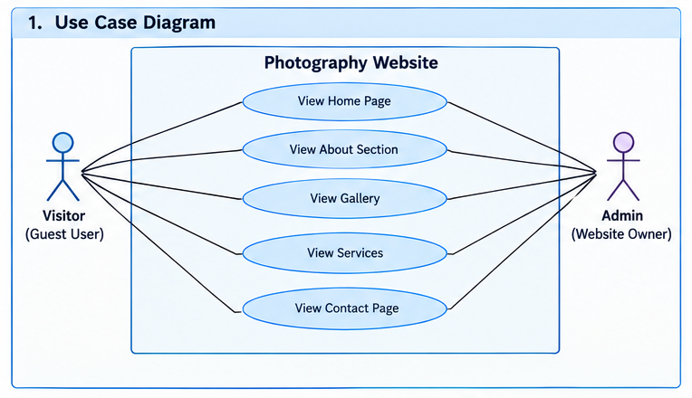

Class Diagram :
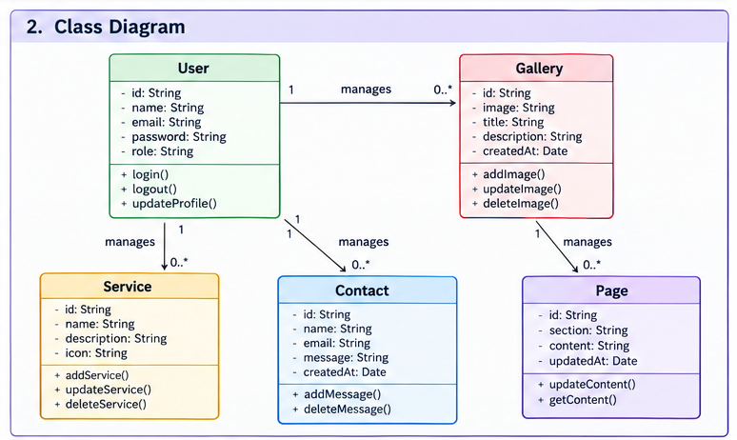

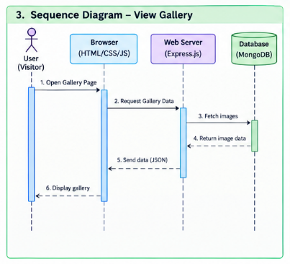
Sequence Diagram :

Activity Diagram :
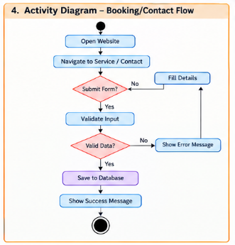

Component Diagram :
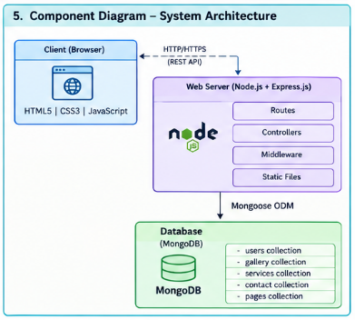

Context Diagram :
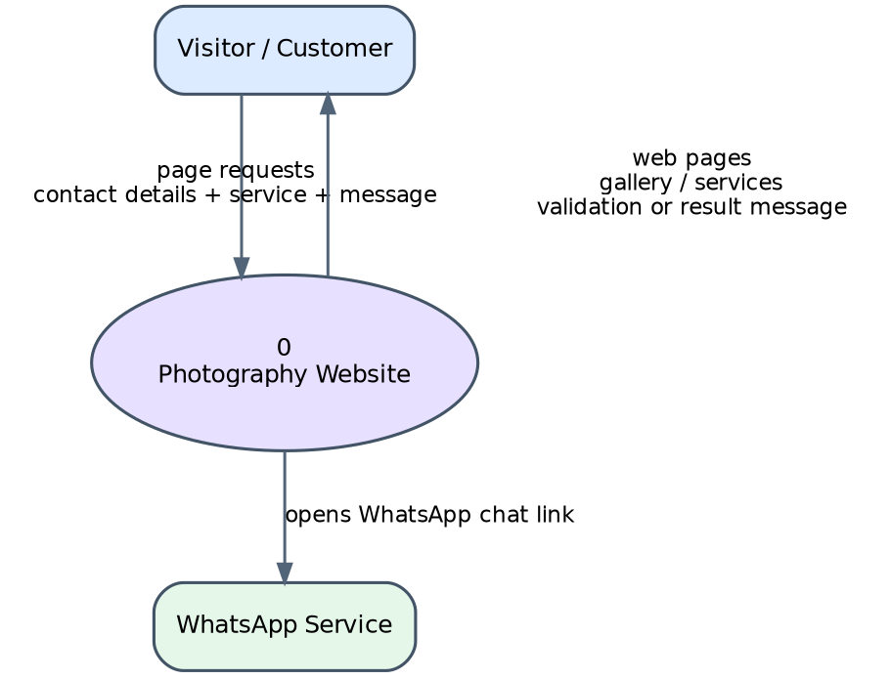

Coding :
Index.html
<!DOCTYPE html>
<html lang="en">
<head>
<meta charset="UTF-8">
<meta name="viewport" content="width=device-width, initial-scale=1.0">
<meta name="description" content="Dipesh Patne Photography & Videography — capturing beautiful moments and creating timeless stories.">
<title>Dipesh Patne | Photography & Videography</title>
<link rel="icon" type="image/svg+xml" href="data:image/svg+xml,%3Csvg xmlns='http://www.w3.org/2000/svg' viewBox='0 0 32 32'%3E%3Crect x='2' y='8' width='28' height='19' rx='3' fill='none' stroke='%23d8c29b' stroke-width='2.4'/%3E%3Cpath d='M11 8l2-3.4h6L21 8' fill='none' stroke='%23d8c29b' stroke-width='2.4' stroke-linejoin='round'/%3E%3Ccircle cx='16' cy='17.5' r='5.4' fill='none' stroke='%23d8c29b' stroke-width='2.4'/%3E%3Ccircle cx='25.4' cy='12.6' r='1.3' fill='%23d8c29b'/%3E%3C/svg%3E">
<link rel="stylesheet" href="style.css">
</head>
<body>
<div class="preloader" id="preloader" aria-hidden="true">
<div class="preloader-inner">
<svg class="preloader-icon" viewBox="0 0 32 32" width="44" height="44" aria-hidden="true">
<rect x="2" y="8" width="28" height="19" rx="3" fill="none" stroke="currentColor" stroke-width="2.4"/>
<path d="M11 8l2-3.4h6L21 8" fill="none" stroke="currentColor" stroke-width="2.4" stroke-linejoin="round"/>
<circle cx="16" cy="17.5" r="5.4" fill="none" stroke="currentColor" stroke-width="2.4"/>
</svg>
<span class="preloader-text">DIPESH PATNE | FILMS</span>
<span class="preloader-bar"><span></span></span>
</div>
</div>
<header class="site-header" id="siteHeader">
<nav class="navbar">
<a class="logo" href="#home">DIPESH PATNE <span class="logo-sep">|</span> FILMS</a>
<button class="menu-btn" id="menuBtn" aria-label="Open menu" aria-expanded="false">☰</button>
<div class="menu" id="menu">
<a href="#home">Home</a>
<a href="#about">About</a>
<a href="#gallery">Gallery</a>
<a href="#services">Services</a>
<a href="#contact">Contact</a>
</div>
</nav>
</header>
<main>
<section id="home" class="hero">
<div class="hero-overlay"></div>
<div class="hero-content">
<p class="eyebrow hero-fade" style="--d:.1s">PHOTOGRAPHY & VIDEOGRAPHY</p>
<h1 class="hero-fade" style="--d:.25s">Capturing<br><em>Beautiful Moments</em></h1>
<p class="hero-copy hero-fade" style="--d:.4s">Turning your special moments into timeless memories.</p>
<a class="button button-hero hero-fade" style="--d:.55s" href="#gallery">View My Work</a>
</div>
<div class="scroll-note hero-fade" style="--d:.9s">SCROLL TO EXPLORE
<svg class="scroll-arrow" viewBox="0 0 12 20" width="10" height="16" aria-hidden="true">
<path d="M6 1v16M2 13l4 4 4-4" fill="none" stroke="currentColor" stroke-width="1.6" stroke-linecap="round" stroke-linejoin="round"/>
</svg>
</div>
</section>
<section id="about" class="section about">
<div class="about-image image-placeholder reveal">
<img src="images/Dipesh.jpg" alt="Dipesh Patne photography">
</div>
<div class="about-text">
<p class="eyebrow reveal">ABOUT ME</p>
<h2 class="reveal" style="--d:.08s">Hi, I'm Dipesh.</h2>
<p class="reveal" style="--d:.16s">I'm a photographer and videographer passionate about capturing real emotions, beautiful moments and stories.</p>
<p class="reveal" style="--d:.24s">From weddings and pre-weddings to portraits and events, I create photographs and films that you can remember for years.</p>
<div class="stats reveal" style="--d:.32s">
<div class="stat">
<span class="stat-number" data-count="50">0</span><span class="stat-plus">+</span>
<span class="stat-label">Shoots Done</span>
</div>
<div class="stat">
<span class="stat-number" data-count="5">0</span><span class="stat-plus">+</span>
<span class="stat-label">Years of Craft</span>
</div>
<div class="stat">
<span class="stat-number" data-count="100">0</span><span class="stat-plus">%</span>
<span class="stat-label">Happy Clients</span>
</div></div>
<a class="button button-dark reveal" style="--d:.4s" href="#contact">Let's Work Together</a>
</div>
</section>
<section id="gallery" class="section gallery-section">
<div class="section-heading">
<p class="eyebrow reveal">SELECTED WORK</p>
<h2 class="reveal" style="--d:.08s">Photography Gallery</h2>
<p class="reveal" style="--d:.16s">A few favourite frames from weddings, portraits and nature — every picture tells a story.</p>
</div>
<div class="gallery">
<button class="gallery-item reveal" data-full="images/Pink.JPG" aria-label="Open photo 1" style="--d:.05s"><img src="\images\Flower1.jpeg" alt="Photography portfolio image 1" loading="lazy">
<span class="gallery-overlay"><svg viewBox="0 0 24 24" width="26" height="26" aria-hidden="true"><path d="M15 3h6v6M9 21H3v-6M21 3l-7 7M3 21l7-7" fill="none" stroke="currentColor" stroke-width="1.8" stroke-linecap="round" stroke-linejoin="round"/></svg></span>
</button>
<button class="gallery-item reveal" data-full="images/Butterfly.jpg" aria-label="Open photo 2" style="--d:.15s">
<img src="images/Butterfly.jpg" alt="Photography portfolio image 2" loading="lazy">
<span class="gallery-overlay"><svg viewBox="0 0 24 24" width="26" height="26" aria-hidden="true"><path d="M15 3h6v6M9 21H3v-6M21 3l-7 7M3 21l7-7" fill="none" stroke="currentColor" stroke-width="1.8" stroke-linecap="round" stroke-linejoin="round"/></svg></span>
</button>
<button class="gallery-item reveal" data-full="images/Trupti&Ganesh.jpg" aria-label="Open photo 3" style="--d:.25s">
<img src="Trupti&Ganesh.jpg" alt="Photography portfolio image 3" loading="lazy">
<span class="gallery-overlay"><svg viewBox="0 0 24 24" width="26" height="26" aria-hidden="true"><path d="M15 3h6v6M9 21H3v-6M21 3l-7 7M3 21l7-7" fill="none" stroke="currentColor" stroke-width="1.8" stroke-linecap="round" stroke-linejoin="round"/></svg></span>
</button>
<button class="gallery-item reveal" data-full="images/photo4.jpg" aria-label="Open photo 4" style="--d:.35s">
<img src="images/photo4.jpg" alt="Photography portfolio image 4" loading="lazy">
<span class="gallery-overlay"><svg viewBox="0 0 24 24" width="26" height="26" aria-hidden="true"><path d="M15 3h6v6M9 21H3v-6M21 3l-7 7M3 21l7-7" fill="none" stroke="currentColor" stroke-width="1.8" stroke-linecap="round" stroke-linejoin="round"/></svg></span>
</button>
</div>
</section>
<section id="services" class="section services">
<div class="section-heading">
<p class="eyebrow reveal">WHAT I DO</p>
<h2 class=images/photo3"reveal" style="--d:.08s">My Services</h2></div>
<div class="service-grid">
<article class="service-card reveal">
<span class="service-icon">
<svg class="service-svg" viewBox="0 0 40 40" width="40" height="40" aria-hidden="true">
<rect x="3" y="10" width="34" height="23" rx="4" fill="none" stroke="currentColor" stroke-width="2.2"/>
<path d="M13.5 10l2.6-4.4h7.8L26.5 10" fill="none" stroke="currentColor" stroke-width="2.2" stroke-linejoin="round"/>
<circle cx="20" cy="21.5" r="6.6" fill="none" stroke="currentColor" stroke-width="2.2"/>
<circle cx="31.5" cy="15.5" r="1.6" fill="currentColor"/></svg>
<i class="service-num">01</i>
</span>
<h3>Photography</h3>
<p>Professional photography for weddings, portraits, events and special moments.</p>
</article>
<article class="service-card reveal" style="--d:.12s">
<span class="service-icon">
<svg class="service-svg" viewBox="0 0 40 40" width="40" height="40" aria-hidden="true">
<rect x="2.5" y="12" width="25" height="18" rx="3.5" fill="none" stroke="currentColor" stroke-width="2.2"/>
<path d="M27.5 18.2l10-4.7v13l-10-4.7z" fill="none" stroke="currentColor" stroke-width="2.2" stroke-linejoin="round"/>
<circle cx="11" cy="17.8" r="2" fill="currentColor"/>
</svg>
<i class="service-num">02</i>
</span>
<h3>Videography</h3>
<p>Cinematic videos and memorable films for your important occasions.</p>
</article>
<article class="service-card reveal" style="--d:.24s">
<span class="service-icon">
<svg class="service-svg" viewBox="0 0 40 40" width="40" height="40" aria-hidden="true">
<circle cx="14.5" cy="20" r="8.2" fill="none" stroke="currentColor" stroke-width="2.2"/>
<circle cx="25.5" cy="20" r="8.2" fill="none" stroke="currentColor" stroke-width="2.2"/>
</svg>
<i class="service-num">03</i>
</span>
<h3>Weddings</h3>
<p>Wedding photography, pre-wedding stories and cinematic wedding films.</p>
</article></div></section>
<section class="section video-section">
<div class="video-copy">
<p class="eyebrow reveal">CINEMATIC STORIES</p>
<h2 class="reveal" style="--d:.08s">Watch the Moments.</h2>
<p class="reveal" style="--d:.16s">Every celebration has a story — I craft it into films you will replay for a lifetime.</p>
<a class="button reveal" style="--d:.24s" href="#contact">Book a Shoot</a></div>
<div class="video-box reveal" style="--d:.15s">
<div class="play" aria-hidden="true">
<svg viewBox="0 0 24 24" width="22" height="22"><path d="M8 5.5v13l11-6.5z" fill="currentColor"/></svg>
</div>
<span>VIDEO / REEL</span></div></section>
<section id="contact" class="section contact">
<div class="section-heading">
<p class="eyebrow reveal">GET IN TOUCH</p>
<h2 class="reveal" style="--d:.08s">Let's Create Something Beautiful</h2>
<p class="reveal" style="--d:.16s">For bookings and enquiries, send a message on WhatsApp or email.</p></div>
<div class="contact-grid">
<div class="contact-card reveal">
<h3>Let's talk</h3>
<p>Fill the form and your enquiry lands straight in my inbox — or reach me directly on any of these.</p>
<a href="https://wa.me/918468811790" class="contact-link" target="_blank" rel="noopener">
<span class="link-ico"><svg viewBox="0 0 24 24" width="17" height="17" aria-hidden="true"><path d="M12 3a9 9 0 0 0-7.8 13.5L3 21l4.6-1.2A9 9 0 1 0 12 3z" fill="none" stroke="currentColor" stroke-width="1.7"/><path d="M9 8.5c.6 2.8 3.7 5.9 6.5 6.5l1-1.6-2.2-1-1 .9c-1-.5-2.1-1.6-2.6-2.6l.9-1-1-2.2z" fill="currentColor"/></svg></span>WhatsApp <em class="arrow">→</em></a>
<a href="mailto:dipeshpatne30@email.com" class="contact-link">
<span class="link-ico"><svg viewBox="0 0 24 24" width="17" height="17" aria-hidden="true"><rect x="3" y="5" width="18" height="14" rx="2.5" fill="none" stroke="currentColor" stroke-width="1.7"/><path d="M4 7l8 6 8-6" fill="none" stroke="currentColor" stroke-width="1.7" stroke-linecap="round" stroke-linejoin="round"/></svg></span>Email <em class="arrow">→</em></a>
<a href="https://instagram.com/dipeshpatnefilms" class="contact-link" target="_blank" rel="noopener">
<span class="link-ico"><svg viewBox="0 0 24 24" width="17" height="17" aria-hidden="true"><rect x="3.5" y="3.5" width="17" height="17" rx="5" fill="none" stroke="currentColor" stroke-width="1.7"/><circle cx="12" cy="12" r="4" fill="none" stroke="currentColor" stroke-width="1.7"/><circle cx="17.2" cy="6.8" r="1.3" fill="currentColor"/></svg></span>Instagram <em class="arrow">→</em></a></div>
<form id="contactForm" class="contact-form reveal" style="--d:.12s" novalidate>
<input type="text" name="name" placeholder="Your Name" required>
<input type="tel" name="phone" placeholder="Phone / WhatsApp" required>
<select name="service" required>
<option value="">Select Service</option>
<option>Wedding Photography</option>
<option>Wedding Videography</option>
<option>Pre-Wedding</option>
<option>Portrait Photography</option>
<option>Event Photography</option>
<option>Other</option>
</select>
<textarea name="message" rows="5" placeholder="Tell me about your event..." required></textarea>
<button class="button button-dark" type="submit" id="submitBtn">
<span class="btn-label">Send Enquiry</span>
</button>
<p class="form-note">Your enquiry is saved to the website database and also opens WhatsApp for a quick chat.</p>
</form></div></section></main>
<footer class="footer">
<h3>DIPESH PATNE</h3><p>Photography & Videography</p>
<div class="socials">
<a href="https://instagram.com/" target="_blank" rel="noopener">Instagram</a>
<a href="https://wa.me/918468811790" target="_blank" rel="noopener">WhatsApp</a></div>
<p class="copyright">© <span id="year"></span> Dipesh Patne Photography. All Rights Reserved.</p>
</footer>
<button class="to-top" id="toTop" aria-label="Back to top">
<svg viewBox="0 0 24 24" width="18" height="18" aria-hidden="true"><path d="M12 20V5M5.5 11.5L12 5l6.5 6.5" fill="none" stroke="currentColor" stroke-width="2" stroke-linecap="round" stroke-linejoin="round"/></svg>
</button>
<div class="toast" id="toast" role="status" aria-live="polite">
<span class="toast-dot" aria-hidden="true"></span>
<span class="toast-msg" id="toastMsg"></span>
</div>
<div class="lightbox" id="lightbox" aria-hidden="true">
<button class="lightbox-close" id="lightboxClose" aria-label="Close image">×</button>
<button class="lightbox-nav lightbox-prev" id="lightboxPrev" aria-label="Previous photo">
<svg viewBox="0 0 24 24" width="22" height="22"><path d="M15 5l-7 7 7 7" fill="none" stroke="currentColor" stroke-width="2" stroke-linecap="round" stroke-linejoin="round"/></svg>
</button>
<button class="lightbox-nav lightbox-next" id="lightboxNext" aria-label="Next photo">
<svg viewBox="0 0 24 24" width="22" height="22"><path d="M9 5l7 7-7 7" fill="none" stroke="currentColor" stroke-width="2" stroke-linecap="round" stroke-linejoin="round"/></svg></button>
<img id="lightboxImage" src="" alt=""></div>
<script src="script.js"></script>
</body></html>
Styles.css
@import url('https://fonts.googleapis.com/css2?family=DM+Sans:wght@400;500;700&family=Playfair+Display:ital,wght@0,500;0,600;1,500;1,600&display=swap');
:root {
--bg: #0d0d0d;
--surface: #151515;
--text: #f4f1eb;
--muted: #aaa49b;
--line: #292929;
--accent: #d8c29b;
--white: #fff;
--max: 1180px;
--ease: cubic-bezier(.22,.61,.36,1);
}
* { box-sizing: border-box; margin: 0; padding: 0; }
html { scroll-behavior: smooth; }
body {
background: var(--bg);
color: var(--text);
font-family: "DM Sans", Arial, sans-serif;
line-height: 1.6;
}
body.no-scroll { overflow: hidden; }
a { color: inherit; }
/* ============ Preloader ============ */
.preloader {
position: fixed;
inset: 0;
z-index: 200;
background: var(--bg);
display: grid;
place-items: center;
transition: opacity .6s ease, visibility .6s ease;
}
.preloader.done { opacity: 0; visibility: hidden; }
.preloader-inner {
display: grid;
justify-items: center;
gap: 18px;
animation: fadeUp .8s var(--ease) both;
}
.preloader-icon { color: var(--accent); animation: pulse 1.6s ease-in-out infinite; }
.preloader-text {
font-size: 11px;
font-weight: 700;
letter-spacing: 4px;
color: var(--text);
}
.preloader-bar {
width: 148px;
height: 2px;
background: var(--line);
overflow: hidden;
border-radius: 2px;
}
.preloader-bar span {
display: block;
width: 40%;
height: 100%;
background: var(--accent);
border-radius: 2px;
animation: loading 1.1s ease-in-out infinite;
}
@keyframes loading {
0% { transform: translateX(-120%); }
100% { transform: translateX(360%); }
}
@keyframes pulse {
0%, 100% { transform: scale(1); opacity: 1; }
50% { transform: scale(1.08); opacity: .75; }
}

/* ============ Header ============ */
.site-header {
position: fixed;
inset: 0 0 auto;
z-index: 50;
background: rgba(10,10,10,.68);
backdrop-filter: blur(12px);
border-bottom: 1px solid rgba(255,255,255,.06);
transition: background .35s ease, box-shadow .35s ease, transform .35s ease;
}
.site-header.scrolled {
background: rgba(8,8,8,.92);
box-shadow: 0 12px 34px rgba(0,0,0,.5);
}
.site-header.hidden-up { transform: translateY(-100%); }
.navbar {
width: min(var(--max), calc(100% - 40px));
margin: auto;
min-height: 76px;
display: flex;
align-items: center;
justify-content: space-between;
}
.logo {
font-size: 15px;
font-weight: 700;
letter-spacing: 3px;
text-decoration: none;
position: relative;
}
.logo-sep { color: var(--accent); margin: 0 2px; }
.menu {
display: flex;
gap: 28px;
align-items: center;
}
.menu a {
text-decoration: none;
color: #ddd;
font-size: 13px;
position: relative;
padding: 6px 2px;
transition: color .25s ease;
}
.menu a::after {
content: "";
position: absolute;
left: 0;
bottom: 0;
width: 100%;
height: 1.5px;
background: var(--accent);
transform: scaleX(0);
transform-origin: right;
transition: transform .35s var(--ease);
}
.menu a:hover,
.menu a.active { color: var(--accent); }
.menu a:hover::after,
.menu a.active::after { transform: scaleX(1); transform-origin: left; }
.menu-btn {
display: none;
border: 0;
background: transparent;
color: white;
font-size: 27px;
cursor: pointer;
transition: transform .3s var(--ease);
}
.menu-btn:active { transform: scale(.9); }
/* ============ Hero ============ */
.hero {
min-height: 100vh;
position: relative;
display: grid;
place-items: center;
text-align: center;
overflow: hidden;
background:
linear-gradient(180deg, rgba(0,0,0,.35), rgba(0,0,0,.74)),
url("images/photo1.jpg") center/cover no-repeat;
animation: heroZoom 9s var(--ease) both;
}
@keyframes heroZoom {
from { transform: scale(1.12); }
to { transform: scale(1); }
}
.hero-overlay {
position: absolute;
inset: 0;
background: radial-gradient(circle at center, transparent 5%, rgba(0,0,0,.35) 75%);
}
.hero-content {
position: relative;
z-index: 1;
width: min(850px, 90%);
padding-top: 60px;
}
.eyebrow {
color: var(--accent);
font-size: 11px;
font-weight: 700;
letter-spacing: 4px;
margin-bottom: 20px;
}
.hero h1 {
font-size: clamp(48px, 8vw, 92px);
line-height: .98;
font-weight: 500;
letter-spacing: -3px;
}
.hero h1 em, h2 em {
font-family: "Playfair Display", serif;
font-weight: 500;
}
.hero h1 em {
background: linear-gradient(100deg, var(--accent) 10%, #f3e6c8 45%, var(--accent) 90%);
background-size: 200% auto;
-webkit-background-clip: text;
background-clip: text;
-webkit-text-fill-color: transparent;
animation: shine 6s linear infinite;
}
@keyframes shine {
to { background-position: 200% center; }
}
.hero-copy {
max-width: 500px;
margin: 25px auto 30px;
color: #ddd;
}
.hero-fade {
opacity: 0;
animation: heroFadeIn 1s var(--ease) both;
animation-delay: var(--d, 0s);
}
@keyframes heroFadeIn {
from { opacity: 0; transform: translateY(28px); }
to { opacity: 1; transform: translateY(0); }
}
.button {
display: inline-flex;
align-items: center;
justify-content: center;
min-height: 50px;
padding: 0 26px;
border: 1px solid rgba(255,255,255,.7);
background: white;
color: #111;
text-decoration: none;
font-weight: 700;
font-size: 13px;
cursor: pointer;
position: relative;
overflow: hidden;
transition: transform .25s var(--ease), background .25s ease, box-shadow .25s ease, color .25s ease;
}
.button::before {
content: "";
position: absolute;
top: 0;
left: -80%;
width: 55%;
height: 100%;
background: linear-gradient(105deg, transparent, rgba(255,255,255,.65), transparent);
transform: skewX(-22deg);
transition: left .55s var(--ease);
}
.button:hover::before { left: 130%; }
.button:hover {
transform: translateY(-2px);
background: #eee;
box-shadow: 0 14px 30px rgba(0,0,0,.35);
}
.button:active { transform: translateY(0); }
.button-hero { border-color: rgba(255,255,255,.85); }
.button-dark {
background: #111;
color: #fff;
border-color: #111;
}
.button-dark::before {
background: linear-gradient(105deg, transparent, rgba(216,194,155,.35), transparent);
}
.button-dark:hover { background: #1c1c1c; }
.scroll-note {
position: absolute;
bottom: 28px;
font-size: 10px;
letter-spacing: 3px;
color: #bbb;
display: grid;
justify-items: center;
gap: 8px;
left: 50%;
transform: translateX(-50%);
}
.scroll-arrow { animation: bob 1.8s ease-in-out infinite; }
@keyframes bob {
0%, 100% { transform: translateY(0); opacity: .6; }
50% { transform: translateY(7px); opacity: 1; }
}
/* ============ Sections & reveal animations ============ */
.section {
width: min(var(--max), calc(100% - 40px));
margin: auto;
padding: 120px 0;
}
.reveal {
opacity: 0;
transform: translateY(34px);
transition: opacity .9s var(--ease), transform .9s var(--ease);
transition-delay: var(--d, 0s);
}
.reveal.visible { opacity: 1; transform: translateY(0); }
/* ============ About ============ */
.about {
display: grid;
grid-template-columns: 1.05fr .95fr;
gap: 80px;
align-items: center;
}
.about-image {
overflow: hidden;
background: #1b1b1b;
position: relative;
}
.about-image::after {
content: "";
position: absolute;
inset: 14px;
/*border: 1px solid rgba(216,194,155,.35);*/
pointer-events: none;
transition: inset .5s var(--ease);
}
.about-image:hover::after { inset: 24px; }
.about-image img {
display: block;
width: 100%;
aspect-ratio: 4/5;
object-fit: cover;
transition: transform .8s var(--ease);
}
.about-image:hover img { transform: scale(1.045); }
.about-text h2, .section-heading h2, .video-copy h2, .contact-card h3 {
font-family: "Playfair Display", Georgia, serif;
font-weight: 500;
}
.about-text h2, .section-heading h2, .video-copy h2 {
font-size: clamp(38px, 5vw, 62px);
line-height: 1.05;
margin-bottom: 25px;
}
.about-text p:not(.eyebrow) {
color: var(--muted);
margin-bottom: 18px;
max-width: 560px;
}
/* stats */
.stats {
display: flex;
gap: 42px;
margin: 30px 0 34px;
padding: 22px 0;
border-top: 1px solid var(--line);
border-bottom: 1px solid var(--line);
}
.stat { display: grid; gap: 2px; }
.stat-number {
font-family: "Playfair Display", Georgia, serif;
font-size: 38px;
color: var(--accent);
line-height: 1.1;
}
.stat-plus {
font-family: "Playfair Display", Georgia, serif;
font-size: 26px;
color: var(--accent);
margin-left: 1px;
}
.stat-label {
font-size: 11px;
letter-spacing: 2px;
color: var(--muted);
text-transform: uppercase;
}
/* ============ Gallery ============ */
.gallery-section { border-top: 1px solid var(--line); }
.section-heading { margin-bottom: 45px; }

.section-heading > p:last-child {
color: var(--muted);
max-width: 650px;
}
.gallery {
display: grid;
grid-template-columns: repeat(2, 1fr);
gap: 14px;
}
.gallery-item {
padding: 0;
border: 0;
overflow: hidden;
background: #171717;
cursor: zoom-in;
position: relative;
}
.gallery-item img {
width: 100%;
aspect-ratio: 4/3;
display: block;
object-fit: cover;
transition: transform .6s var(--ease), filter .6s ease;
}
.gallery-overlay {
position: absolute;
inset: 0;
display: grid;
place-items: center;
color: #fff;
background: rgba(0,0,0,.42);
opacity: 0;
transition: opacity .4s ease;
}
.gallery-overlay svg { transform: scale(.6); transition: transform .45s var(--ease); }
.gallery-item:hover img { transform: scale(1.06); filter: saturate(1.12); }
.gallery-item:hover .gallery-overlay { opacity: 1; }
.gallery-item:hover .gallery-overlay svg { transform: scale(1); }
.gallery-item:focus-visible { outline: 2px solid var(--accent); outline-offset: 3px; }
/* ============ Services ============ */
.services { border-top: 1px solid var(--line); }
.service-grid {
display: grid;
grid-template-columns: repeat(3, 1fr);
gap: 14px;
}
.service-card {
min-height: 260px;
padding: 35px;
background: var(--surface);
border: 1px solid var(--line);
position: relative;
overflow: hidden;
transition: transform .4s var(--ease), border-color .4s ease, background .4s ease;
}
.service-card::before {
content: "";
position: absolute;
left: 0;
top: 0;
width: 100%;
height: 3px;
background: linear-gradient(90deg, var(--accent), transparent);
transform: scaleX(0);
transform-origin: left;
transition: transform .5s var(--ease);
}
.service-card:hover {
transform: translateY(-7px);
border-color: rgba(216,194,155,.4);
background: #181614;
}
.service-card:hover::before { transform: scaleX(1); }
.service-icon {
color: var(--accent);
font-size: 12px;
letter-spacing: 2px;
display: grid;
gap: 14px;
justify-items: start;
}
.service-svg { transition: transform .5s var(--ease); }
.service-card:hover .service-svg { transform: translateY(-4px) rotate(-3deg); }
.service-num { font-style: normal; font-size: 12px; letter-spacing: 2px; }
.service-card h3 {
margin: 40px 0 12px;
font-family: "Playfair Display", Georgia, serif;
font-size: 28px;
font-weight: 500;
}
.service-card p { color: var(--muted); }
/* ============ Video section ============ */
.video-section {
display: grid;
grid-template-columns: .85fr 1.15fr;
gap: 60px;
align-items: center;
border-top: 1px solid var(--line);
}
.video-copy p:not(.eyebrow) {
color: var(--muted);
margin-bottom: 25px;
}
.video-box {
min-height: 400px;
background:
linear-gradient(rgba(0,0,0,.2), rgba(0,0,0,.65)),
url("images/photo4.jpg") center/cover no-repeat;
display: grid;
place-items: center;
align-content: center;
gap: 12px;
border: 1px solid var(--line);
position: relative;
cursor: pointer;
transition: border-color .4s ease;
}
.video-box:hover { border-color: rgba(216,194,155,.45); }
.video-box::after {
content: "";
position: absolute;
inset: 0;
background: radial-gradient(circle at center, rgba(216,194,155,.12), transparent 55%);
opacity: 0;
transition: opacity .45s ease;
}
.video-box:hover::after { opacity: 1; }
.play {
width: 72px;
height: 72px;
border: 1px solid rgba(255,255,255,.7);
border-radius: 50%;
display: grid;
place-items: center;
color: #fff;
position: relative;
z-index: 1;
transition: transform .35s var(--ease), background .35s ease;
}
.play::before,
.play::after {
content: "";
position: absolute;
inset: -1px;
border-radius: 50%;
border: 1px solid rgba(255,255,255,.4);
animation: ripple 2.6s ease-out infinite;
}
.play::after { animation-delay: 1.3s; }
@keyframes ripple {
0% { transform: scale(1); opacity: 1; }
100% { transform: scale(1.85); opacity: 0; }
}
.video-box:hover .play { transform: scale(1.1); background: rgba(216,194,155,.18); }
.video-box span {
font-size: 10px;
letter-spacing: 3px;
position: relative;
z-index: 1;}
/* ============ Contact ============ */
.contact { border-top: 1px solid var(--line); }
.contact-grid {
display: grid;
grid-template-columns: .8fr 1.2fr;
gap: 70px;
}
.contact-card h3 {
font-size: 42px;
margin-bottom: 18px;
}
.contact-card > p { color: var(--muted); margin-bottom: 25px; }
.contact-link {
display: flex;
align-items: center;
gap: 12px;
width: fit-content;
padding: 10px 0;
text-decoration: none;
border-bottom: 1px solid var(--line);
transition: color .25s ease, border-color .25s ease, transform .3s var(--ease);
}
.contact-link .link-ico { color: var(--muted); display: grid; place-items: center; transition: color .25s ease, transform .3s var(--ease); }
.contact-link .arrow { font-style: normal; transition: transform .3s var(--ease); }
.contact-link:hover { color: var(--accent); border-color: rgba(216,194,155,.4); transform: translateX(4px); }
.contact-link:hover .link-ico { color: var(--accent); transform: translateY(-2px); }
.contact-link:hover .arrow { transform: translateX(4px); }
.contact-form {
display: grid;
gap: 14px;
}
input, textarea, select {
width: 100%;
border: 1px solid var(--line);
background: #151515;
color: #fff;
padding: 16px;
font: inherit;
outline: none;
transition: border-color .3s ease, background .3s ease, transform .3s var(--ease), box-shadow .3s ease;
}
input::placeholder, textarea::placeholder { color: #6f6a62; }
input:focus, textarea:focus, select:focus {
border-color: var(--accent);
background: #181615;
box-shadow: 0 0 0 3px rgba(216,194,155,.09);
}
input.invalid, textarea.invalid, select.invalid { border-color: #c0574f; animation: shake .4s ease; }
@keyframes shake {
0%, 100% { transform: translateX(0); }
25% { transform: translateX(-5px); }
75% { transform: translateX(5px); }
}
textarea { resize: vertical; }
select option { background: #151515; }
#submitBtn { position: relative; }
#submitBtn.loading { pointer-events: none; opacity: .85; }
#submitBtn.loading .btn-label { display: inline-flex; align-items: center; gap: 10px; }
#submitBtn.loading .btn-label::before {
content: "";
width: 14px;
height: 14px;
border: 2px solid rgba(255,255,255,.35);
border-top-color: #fff;
border-radius: 50%;
animation: spin .7s linear infinite;
}
@keyframes spin { to { transform: rotate(360deg); } }
.form-note { font-size: 12px; color: var(--muted); }
/* ============ Footer ============ */
.footer {
padding: 55px 20px;
text-align: center;
border-top: 1px solid var(--line);
}
.footer h3 { letter-spacing: 3px; font-size: 15px; }
.footer p { color: var(--muted); margin-top: 8px; }
.socials { margin: 22px 0; display: flex; justify-content: center; gap: 20px; }
.socials a { text-decoration: none; font-size: 13px; position: relative; }
.socials a::after {
content: "";
position: absolute;
left: 0;
bottom: -3px;
width: 100%;
height: 1px;
background: var(--accent);
transform: scaleX(0);
transition: transform .3s var(--ease);
}
.socials a:hover { color: var(--accent); }
.socials a:hover::after { transform: scaleX(1); }
.copyright { font-size: 11px; }
/* ============ Toast ============ */
.toast {
position: fixed;
bottom: 26px;
left: 50%;
transform: translate(-50%, 140%);
z-index: 150;
display: flex;
align-items: center;
gap: 10px;
max-width: min(440px, calc(100vw - 40px));
padding: 14px 22px;
background: #1c1a17;
border: 1px solid rgba(216,194,155,.35);
color: var(--text);
font-size: 14px;
box-shadow: 0 18px 46px rgba(0,0,0,.55);
transition: transform .5s var(--ease);
}
.toast.show { transform: translate(-50%, 0); }
.toast-dot {
width: 8px;
height: 8px;
border-radius: 50%;
background: var(--accent);
flex: 0 0 auto;
animation: pulse 1.4s ease-in-out infinite;
}
/* ============ Back to top ============ */
.to-top {
position: fixed;
right: 26px;
bottom: 26px;
z-index: 90;
width: 46px;
height: 46px;
border: 1px solid rgba(216,194,155,.4);
background: rgba(13,13,13,.85);
backdrop-filter: blur(8px);
color: var(--accent);
display: grid;
place-items: center;
cursor: pointer;
opacity: 0;
visibility: hidden;
transform: translateY(14px);
transition: opacity .35s ease, visibility .35s ease, transform .35s var(--ease), background .3s ease;
}
.to-top.show { opacity: 1; visibility: visible; transform: translateY(0); }
.to-top:hover { background: rgba(216,194,155,.15); }
/* ============ Lightbox ============ */
.lightbox {
position: fixed;
inset: 0;
z-index: 100;
background: rgba(0,0,0,.94);
display: none;
place-items: center;
padding: 30px;
}
.lightbox.open { display: grid; }
.lightbox.open img {
animation: zoomIn .45s var(--ease) both;
}
@keyframes zoomIn {
from { opacity: 0; transform: scale(.92); }
to { opacity: 1; transform: scale(1); }
}
.lightbox img {
max-width: 94vw;
max-height: 88vh;
object-fit: contain;
}
.lightbox-close {
position: absolute;
top: 20px;
right: 25px;
background: transparent;
border: 0;
color: white;
font-size: 42px;
cursor: pointer;
line-height: 1;
transition: transform .3s var(--ease), color .3s ease;
}
.lightbox-close:hover { transform: rotate(90deg); color: var(--accent); }
.lightbox-nav {
position: absolute;
top: 50%;
transform: translateY(-50%);
width: 52px;
height: 52px;
border: 1px solid rgba(255,255,255,.25);
border-radius: 50%;
background: rgba(20,20,20,.6);
color: #fff;
display: grid;
place-items: center;
cursor: pointer;
transition: background .3s ease, border-color .3s ease, color .3s ease;
}
.lightbox-nav:hover { background: rgba(216,194,155,.22); border-color: var(--accent); color: var(--accent); }
.lightbox-prev { left: 26px; }
.lightbox-next { right: 26px; }
/* ============ Keyframes shared ============ */
@keyframes fadeUp {
from { opacity: 0; transform: translateY(20px); }
to { opacity: 1; transform: translateY(0); }
}
/* ============ Responsive ============ */
@media (max-width: 800px) {
.menu-btn { display: block; }
.menu {
display: none;
position: absolute;
top: 76px;
left: 0;
width: 100%;
padding: 20px;
background: rgba(10,10,10,.98);
flex-direction: column;
align-items: stretch;
text-align: center;
gap: 8px;
}
.menu.open { display: flex; animation: fadeUp .35s var(--ease) both; }
.menu a { padding: 12px; }
.about, .video-section, .contact-grid { grid-template-columns: 1fr; gap: 40px; }
.service-grid { grid-template-columns: 1fr; }
.gallery { grid-template-columns: 1fr; }
.section { padding: 85px 0; }
.video-box { min-height: 300px; }
.stats { gap: 26px; justify-content: space-between; }
.lightbox-nav { width: 44px; height: 44px; }
.lightbox-prev { left: 12px; }
.lightbox-next { right: 12px; }
}
@media (max-width: 480px) {
.navbar { width: min(100% - 28px, var(--max)); }
.section { width: min(100% - 28px, var(--max)); }
.hero h1 { letter-spacing: -1.5px; }
.stats { flex-wrap: wrap; }
.to-top { right: 16px; bottom: 16px; }
}
/* ============ Accessibility ============ */
@media (prefers-reduced-motion: reduce) {
*, *::before, *::after {
animation-duration: .01ms !important;
animation-iteration-count: 1 !important;
transition-duration: .01ms !important;
}
html { scroll-behavior: auto; }
.hero-fade, .reveal { opacity: 1 !important; transform: none !important; }
}

Script.js
/* ============================================================
Dipesh Patne | Films — frontend script
- UI: menu, lightbox, reveal animations, counters, toasts
- Backend: saves enquiries to the Django API, falls back to WhatsApp
============================================================ */
const API_BASE = "http://127.0.0.1:8000/api";
const WHATSAPP_NUMBER = "918468811790"; // business WhatsApp number
/* ---------- Preloader ---------- */
const preloader = document.getElementById("preloader");
window.addEventListener("load", () => {
setTimeout(() => preloader?.classList.add("done"), 450);
});
// Safety: never trap the user behind the preloader
setTimeout(() => preloader?.classList.add("done"), 3500);
/* ---------- Mobile menu ---------- */
const menuBtn = document.getElementById("menuBtn");
const menu = document.getElementById("menu");
menuBtn?.addEventListener("click", () => {
const open = menu.classList.toggle("open");
menuBtn.textContent = open ? "×" : "☰";
menuBtn.setAttribute("aria-expanded", String(open));
menuBtn.setAttribute("aria-label", open ? "Close menu" : "Open menu");
});
document.querySelectorAll(".menu a").forEach(link => {
link.addEventListener("click", () => {
menu.classList.remove("open");
if (menuBtn) menuBtn.textContent = "☰";
});
});
/* ---------- Header state + active link + back-to-top ---------- */
const header = document.getElementById("siteHeader");
const toTop = document.getElementById("toTop");
const navLinks = [...document.querySelectorAll(".menu a")];
const sections = navLinks
.map(a => document.querySelector(a.getAttribute("href")))
.filter(Boolean);
let lastScroll = 0;
function onScroll() {
const y = window.scrollY;
header?.classList.toggle("scrolled", y > 40);
// hide header when scrolling down, show when scrolling up (mobile-friendly)
if (y > 300 && y > lastScroll + 6) header?.classList.add("hidden-up");
else if (y < lastScroll - 6 || y < 300) header?.classList.remove("hidden-up");
lastScroll = y;
toTop?.classList.toggle("show", y > 700);
// active section highlight
let currentId = "";
sections.forEach(sec => {
if (y >= sec.offsetTop - 140) currentId = sec.id;
});
navLinks.forEach(a => {
a.classList.toggle("active", a.getAttribute("href") === `#${currentId}`);
});
}
window.addEventListener("scroll", onScroll, { passive: true });
onScroll();
toTop?.addEventListener("click", () => {
window.scrollTo({ top: 0, behavior: "smooth" });
});
/* ---------- Reveal on scroll ---------- */
const revealEls = document.querySelectorAll(".reveal");
if ("IntersectionObserver" in window) {
const revealObserver = new IntersectionObserver(entries => {
entries.forEach(entry => {
if (entry.isIntersecting) {
entry.target.classList.add("visible");
revealObserver.unobserve(entry.target);
}
});
}, { threshold: 0.16, rootMargin: "0px 0px -40px 0px" });
revealEls.forEach(el => revealObserver.observe(el));
} else {
revealEls.forEach(el => el.classList.add("visible"));
}
/* ---------- Animated counters ---------- */
const counters = document.querySelectorAll(".stat-number");
function animateCounter(el) {
const target = parseInt(el.dataset.count || "0", 10);
const duration = 1600;
const start = performance.now();
function tick(now) {
const progress = Math.min((now - start) / duration, 1);
// ease-out for a satisfying slowdown at the end
const eased = 1 - Math.pow(1 - progress, 3);
el.textContent = Math.round(target * eased);
if (progress < 1) requestAnimationFrame(tick);
}
requestAnimationFrame(tick);
}
if ("IntersectionObserver" in window) {
const counterObserver = new IntersectionObserver(entries => {
entries.forEach(entry => {
if (entry.isIntersecting) {
animateCounter(entry.target);
counterObserver.unobserve(entry.target);
}
});
}, { threshold: 0.6 });
counters.forEach(c => counterObserver.observe(c));
} else {
counters.forEach(c => { c.textContent = c.dataset.count; });
}
/* ---------- Lightbox with prev / next ---------- */
const lightbox = document.getElementById("lightbox");
const lightboxImage = document.getElementById("lightboxImage");
const lightboxClose = document.getElementById("lightboxClose");
const lightboxPrev = document.getElementById("lightboxPrev");
const lightboxNext = document.getElementById("lightboxNext");
const galleryItems = [...document.querySelectorAll(".gallery-item")];
let currentPhoto = 0;
function showPhoto(index) {
if (!galleryItems.length) return;
currentPhoto = (index + galleryItems.length) % galleryItems.length;
const item = galleryItems[currentPhoto];
lightboxImage.src = item.dataset.full;
lightboxImage.alt = item.querySelector("img")?.alt || "Portfolio image";
}
function openLightbox(index) {
if (!lightbox || !lightboxImage) return;
showPhoto(index);
lightbox.classList.add("open");
lightbox.setAttribute("aria-hidden", "false");
document.body.classList.add("no-scroll");
}
function closeLightbox() {
if (!lightbox || !lightboxImage) return;
lightbox.classList.remove("open");
lightbox.setAttribute("aria-hidden", "true");
document.body.classList.remove("no-scroll");
lightboxImage.src = "";
}
galleryItems.forEach((item, index) => {
item.addEventListener("click", () => openLightbox(index));
});
lightboxClose?.addEventListener("click", closeLightbox);
lightboxPrev?.addEventListener("click", () => showPhoto(currentPhoto - 1));
lightboxNext?.addEventListener("click", () => showPhoto(currentPhoto + 1));
lightbox?.addEventListener("click", event => {
if (event.target === lightbox) closeLightbox();
});
document.addEventListener("keydown", event => {
if (!lightbox?.classList.contains("open")) return;
if (event.key === "Escape") closeLightbox();
if (event.key === "ArrowLeft") showPhoto(currentPhoto - 1);
if (event.key === "ArrowRight") showPhoto(currentPhoto + 1);
});
// swipe support for touch devices
let touchStartX = null;
lightbox?.addEventListener("touchstart", e => { touchStartX = e.touches[0].clientX; }, { passive: true });
lightbox?.addEventListener("touchend", e => {
if (touchStartX === null) return;
const dx = e.changedTouches[0].clientX - touchStartX;
if (Math.abs(dx) > 46) showPhoto(currentPhoto + (dx < 0 ? 1 : -1));
touchStartX = null;
}, { passive: true });
/* ---------- Footer year ---------- */
const year = document.getElementById("year");
if (year) year.textContent = new Date().getFullYear();
/* ---------- Toast notifications ---------- */
const toast = document.getElementById("toast");
const toastMsg = document.getElementById("toastMsg");
let toastTimer = null;
function showToast(message, duration = 4200) {
if (!toast || !toastMsg) return;
toastMsg.textContent = message;
toast.classList.add("show");
clearTimeout(toastTimer);
toastTimer = setTimeout(() => toast.classList.remove("show"), duration);
}
/* ---------- Contact form: save to backend, then WhatsApp ---------- */
const form = document.getElementById("contactForm");
const submitBtn = document.getElementById("submitBtn");
function markInvalid(el, invalid) {
el.classList.toggle("invalid", invalid);
}
form?.addEventListener("submit", async event => {
event.preventDefault();
const data = new FormData(form);
const enquiry = {
name: String(data.get("name") || "").trim(),
phone: String(data.get("phone") || "").trim(),
service: String(data.get("service") || "").trim(),
message: String(data.get("message") || "").trim(),
};
// light client-side validation with visual feedback
let valid = true;
["name", "phone", "service", "message"].forEach(key => {
const el = form.elements[key];
const ok = enquiry[key].length > 0;
markInvalid(el, !ok);
if (!ok) valid = false;
});
if (!valid) {
showToast("Please fill in every field so I can get back to you.");
return;
}
if (submitBtn) submitBtn.classList.add("loading");
const whatsappText =
`Hello Dipesh, I would like to make an enquiry.\n\n` +
`Name: ${enquiry.name}\n` +
`Phone: ${enquiry.phone}\n` +
`Service: ${enquiry.service}\n` +
`Message: ${enquiry.message}`;
let saved = false;
try {
const response = await fetch(`${API_BASE}/enquiries/`, {
method: "POST",
headers: { "Content-Type": "application/json" },
body: JSON.stringify(enquiry),
});
saved = response.ok;
} catch (error) {
console.warn("Could not reach Django backend; continuing with WhatsApp fallback.", error);
} finally {
if (submitBtn) submitBtn.classList.remove("loading");
}
if (saved) {
showToast("Thank you! Your enquiry was saved. Opening WhatsApp…");
form.reset();
} else {
showToast("Could not reach the server — WhatsApp will open so you can still send it.");
}
window.open(
`https://wa.me/${WHATSAPP_NUMBER}?text=${encodeURIComponent(whatsappText)}`,
"_blank",
"noopener"
);
});
/* clear the invalid style as the user types */
["input", "change"].forEach(evt => {
form?.addEventListener(evt, e => {
if (e.target.classList?.contains("invalid")) markInvalid(e.target, false); }); });

Working Website Screenshots
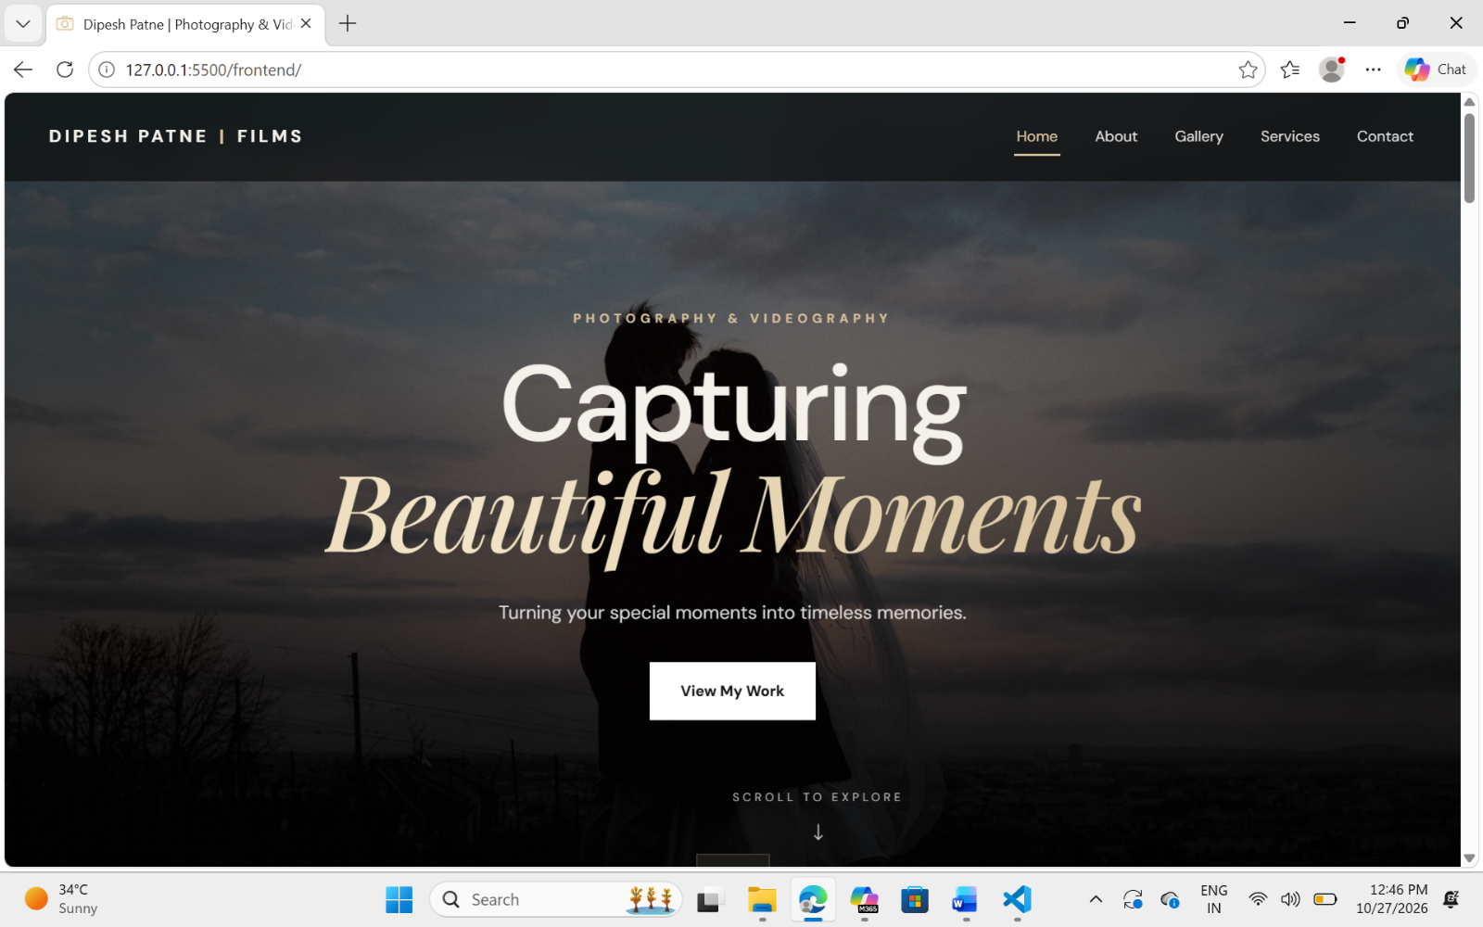
1.Home Page:

2.About Page:
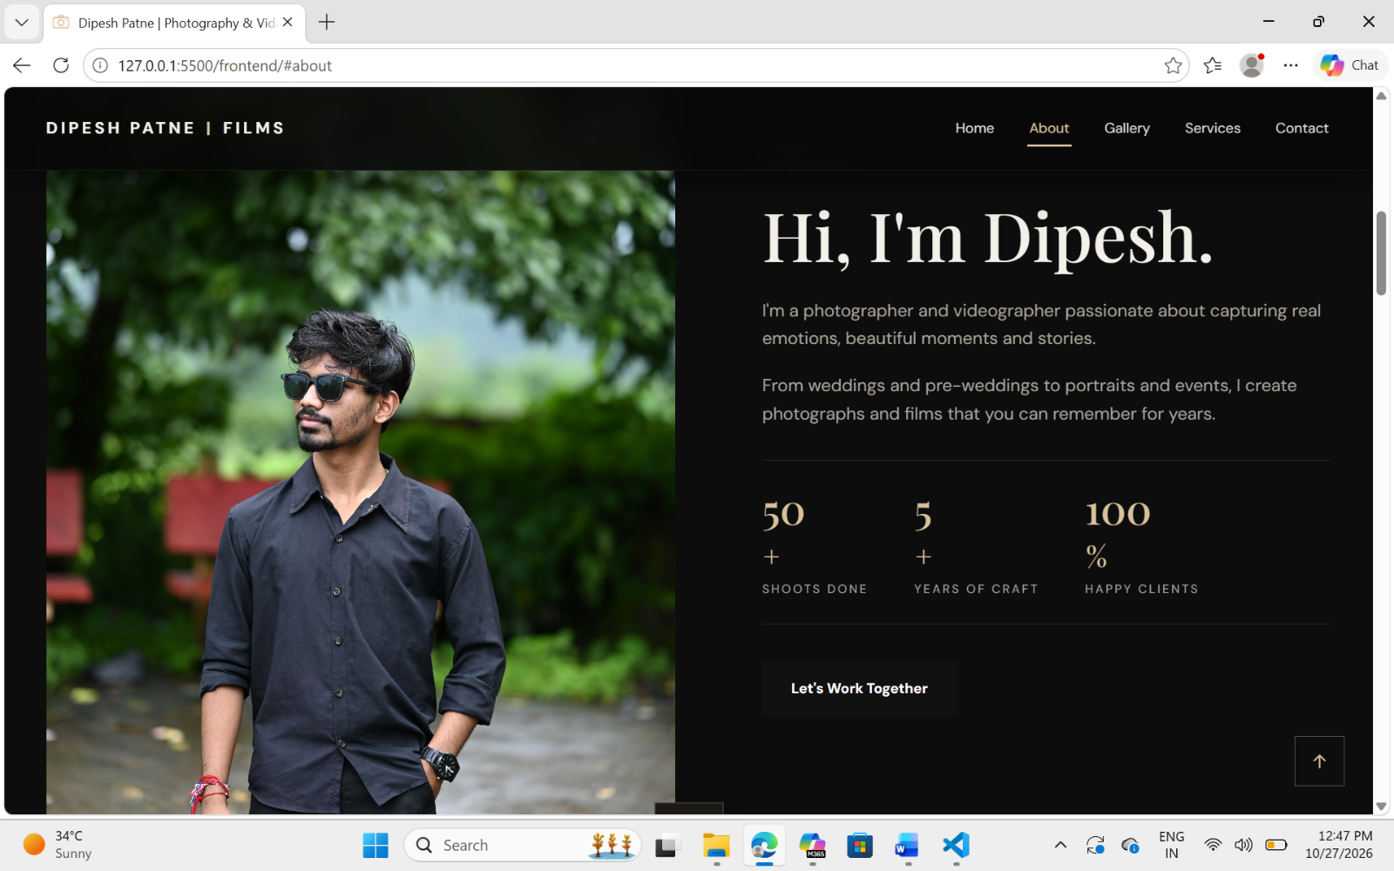

3.Services Page
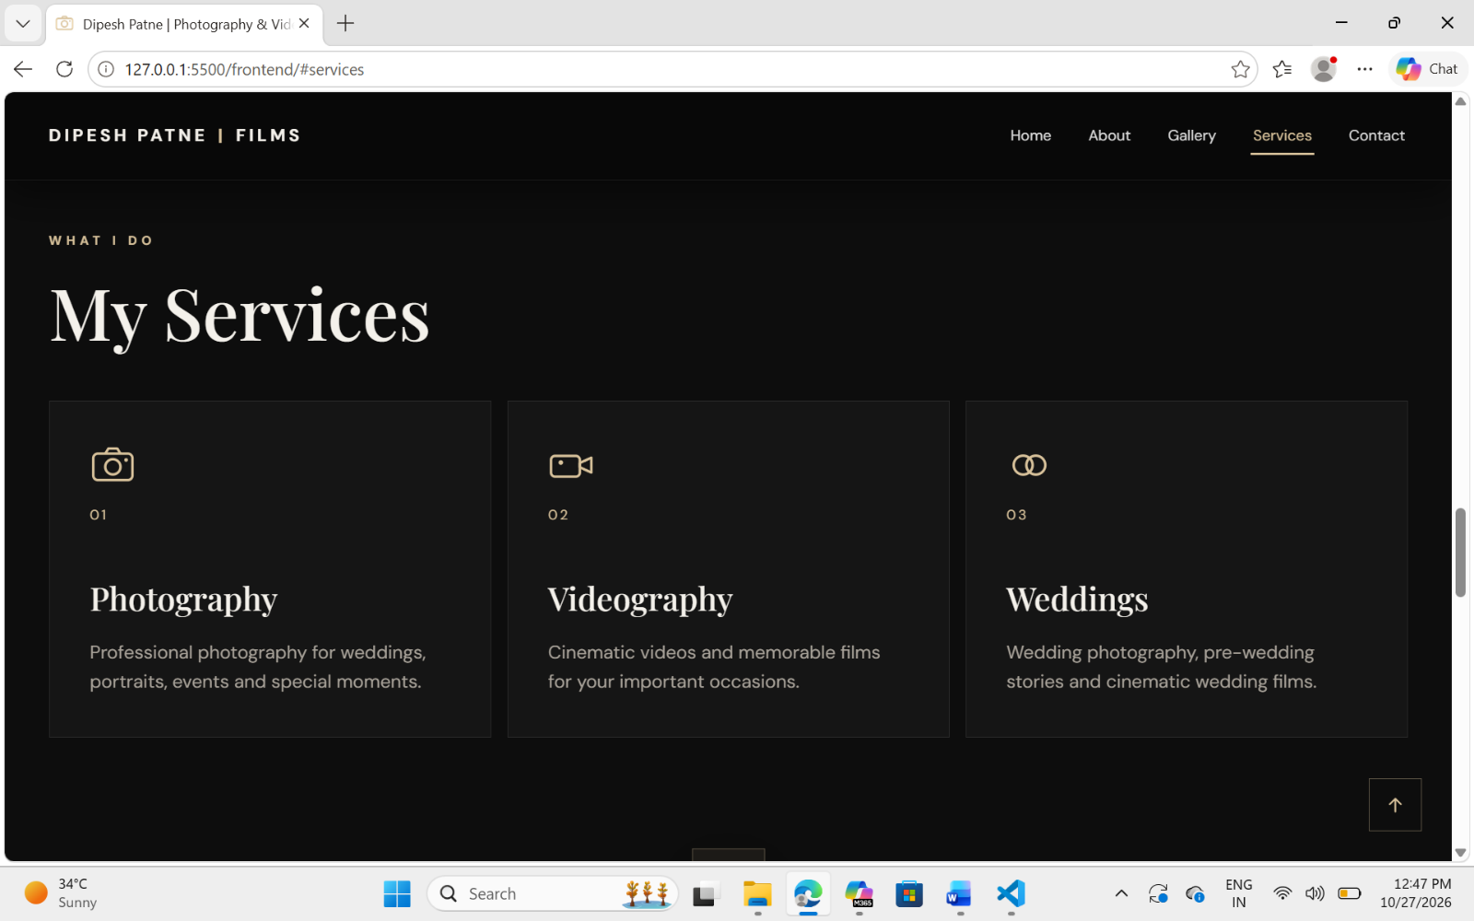

4.Booking Animation page:
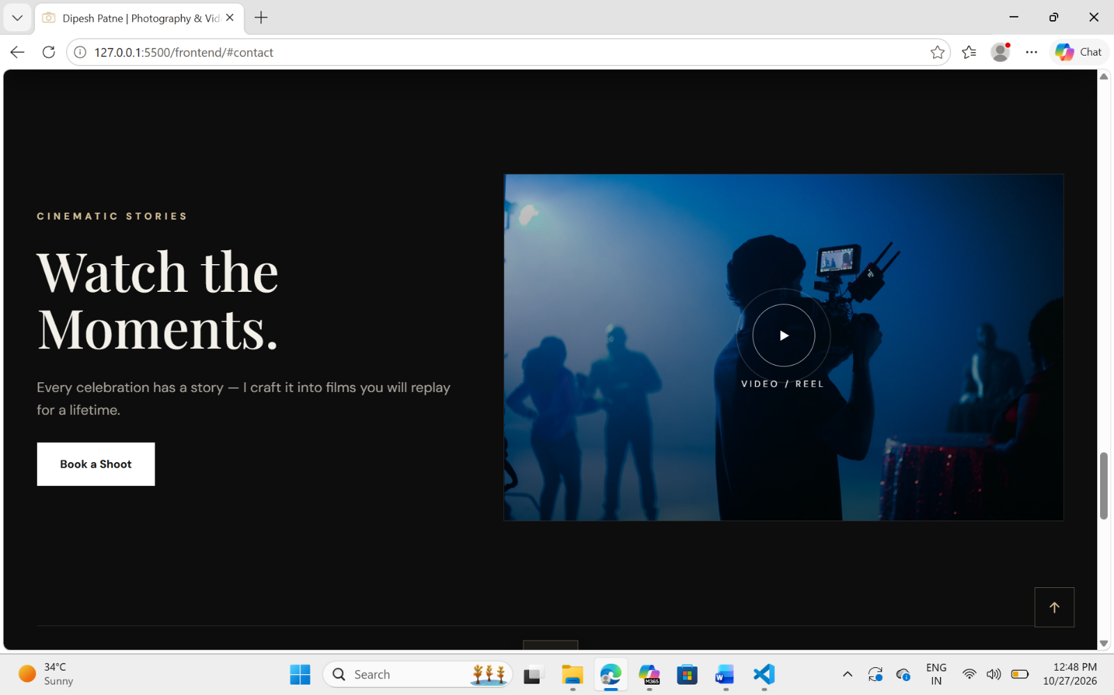

5.Contact Page:
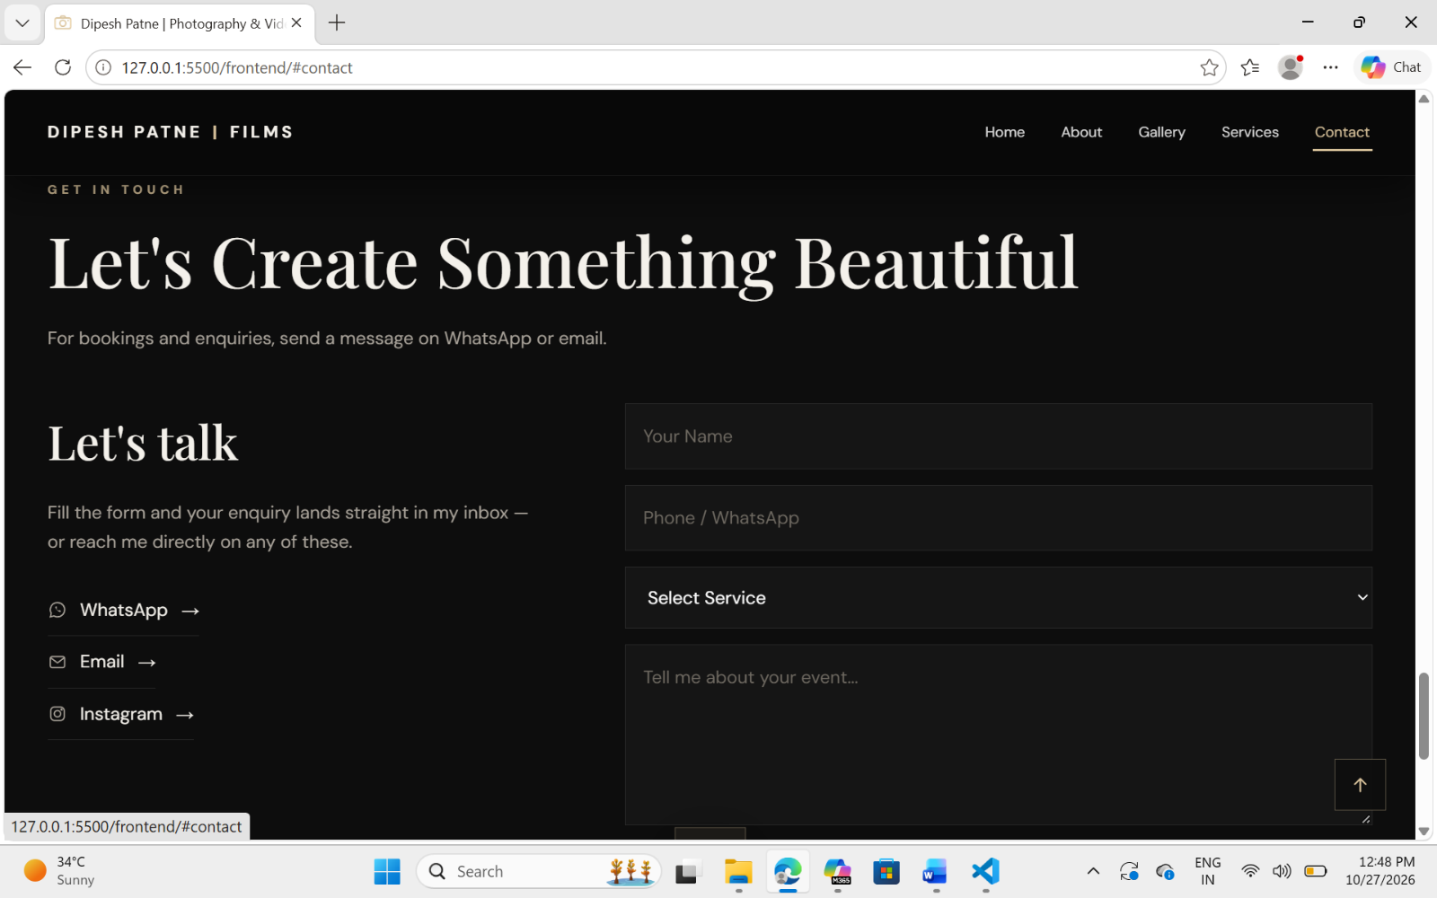

6.Gallery Page:
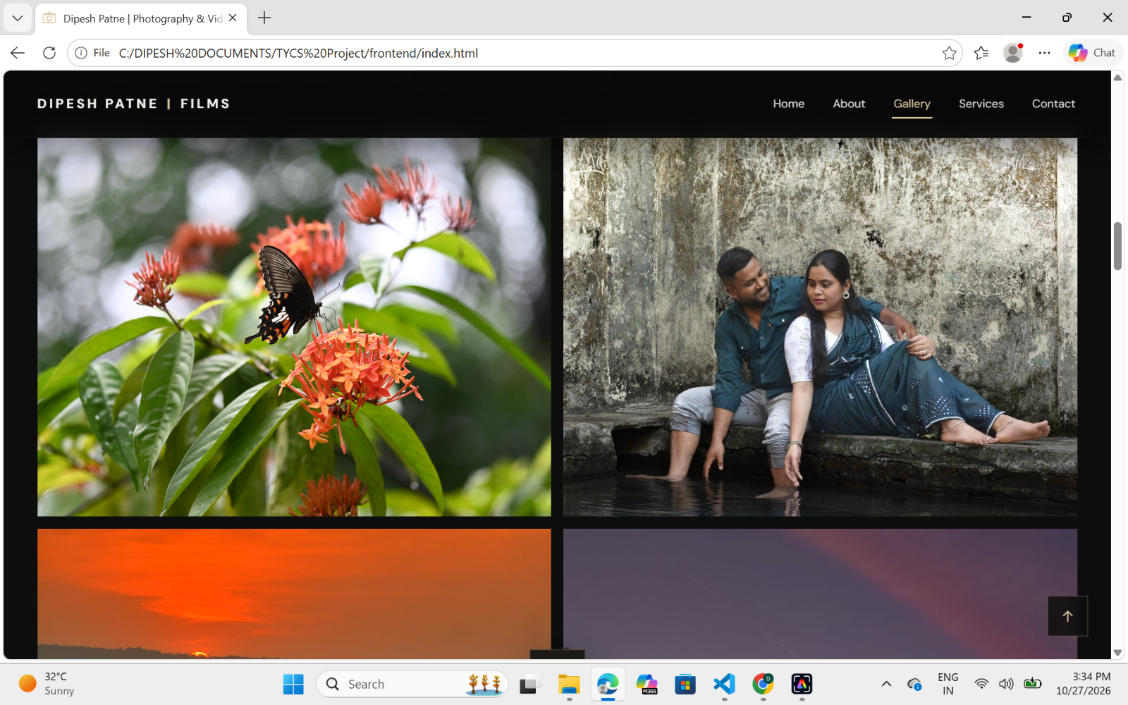

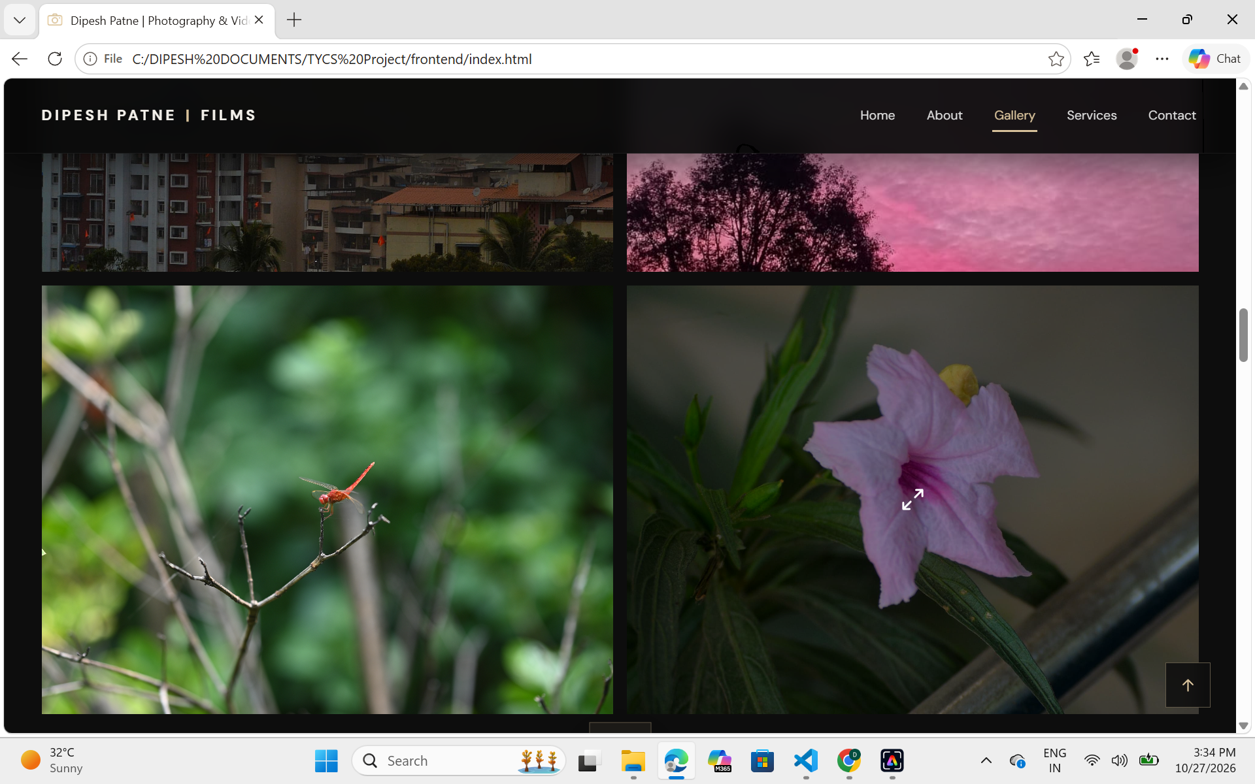

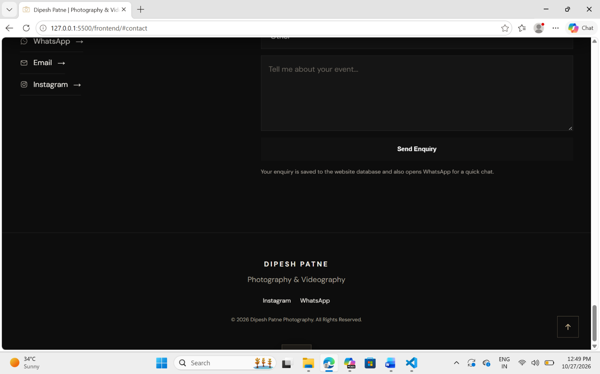
7.Footer Section

CHAPTER 5 : RESULT AND CONCLUSION

5.1 Result
The Photography Website was designed and developed to showcase photography and videography services and provide an easy way for visitors to explore the photographer’s work and make enquiries. The website presents the photographer’s profile, portfolio, services, and contact information through a structured and visually appealing interface.
The website includes the following features:
- Home Page: Introduces the photographer and highlights the photography and videography services.
- About Section: Provides information about the photographer, experience, and work.
- Photography Gallery: Displays selected photographs in an organized gallery with an image-viewing feature.
- Services Section: Presents the available services, including photography, videography, and wedding photography.
- Video Section: Provides a dedicated area for showcasing cinematic videos and reels.
- Contact Section: Includes an enquiry form where visitors can enter their name, phone number, required service, and message.
- Communication Links: Provides links to WhatsApp, email, and Instagram to make communication easier.
- Interactive Interface: Includes navigation, visual effects, a loading screen, notifications, and image-viewing controls to improve the user experience.
The website uses HTML to structure the content, CSS to control the appearance and layout, and JavaScript to support interactive features. The design aims to make the photographer’s portfolio accessible and easy to navigate.
The contact form interface is implemented in the provided frontend code. Successful database storage of enquiries depends on the availability and correct integration of the backend and database services.

5.2 Conclusion
The Photography Website project demonstrates how web technologies can be used to create a professional online portfolio for a photography and videography business. It provides a centralized platform for presenting photographs, describing services, introducing the photographer, and allowing potential customers to make enquiries.
The project helped in understanding the practical application of HTML, CSS, and JavaScript in website development, including page structure, responsive navigation, gallery presentation, form design, and interactive user-interface elements.
The website can help improve the online visibility of a photography business and make it easier for potential customers to view its work and contact the photographer. Its modular structure also allows new features to be added in the future.
Further development may include integrating a fully functional backend and database for storing enquiries, adding customer and booking management, maintaining service packages and pricing, tracking payments, generating invoices, and creating administrative reports.
In conclusion, the project provides a useful foundation for a photography business website and can be extended into a complete Photography Business Management System with additional backend functionality.
The development of this project also improved practical knowledge of frontend design and web development techniques. The website is designed to provide a smooth browsing experience across different devices and screen sizes. It helps present photography work in an organized manner and makes important service and contact details easily accessible to visitors.
In the future, the system can be enhanced with customer registration, online booking, secure payment processing, and an administration dashboard. These improvements can help automate business operations and reduce manual work. Overall, this project provides a strong foundation for developing a more complete and efficient photography business management system. It also demonstrates the importance of technology in promoting creative services and improving communication between photographers and their customers.

5.3 FUTURE SCOPE
The Photography Business Management System can be enhanced in the future by adding new features to make the system more efficient, secure, and user-friendly. The following improvements can be implemented in future versions of the project.
- Online Booking System: A dedicated booking facility can allow customers to check availability, select photography packages, and request bookings online.
- Online Payment Integration: Secure payment gateways can be integrated to support online payments, advance deposits, and balance payments.
- Customer Portal: A customer portal can be developed to allow clients to view booking details, check booking status, and access invoices and payment records.
- Photo Upload and Gallery Delivery: The system can provide a facility to upload, organize, and securely share edited photographs and videos with customers.
- Automated Notifications: Email and SMS notifications can be added to remind customers and the studio owner about upcoming bookings, pending payments, and delivery dates.
- Mobile Application: A mobile application can be developed to help photographers manage bookings, customer details, and payment information while working at different locations.
- Staff and Equipment Management: Future versions can include staff assignment, attendance, payroll, and inventory management for cameras, lenses, lighting equipment, and other studio resources.
- Advanced Reports and Analytics: The system can generate detailed reports about revenue, bookings, customer activity, popular packages, and outstanding payments to support better business decisions.
- Improved Security and Backup: Additional security measures, access controls, and automatic database backups can help protect business information and reduce the risk of data loss.
- Cloud-Based Expansion: The system can be enhanced to support more studios, improved scalability, and access to business information from different devices through cloud hosting.
In conclusion, these future enhancements can transform the current system into a complete photography business management solution. They can reduce manual work, improve customer communication, simplify business operations, and help photography studios manage their activities more effectively.

5.4 REFERENCES / BIBLIOGRAPHY
- MDN Web Docs, “HTML: HyperText Markup Language.” Available at: https://developer.mozilla.org/en-US/docs/Web/HTML
- MDN Web Docs, “CSS: Cascading Style Sheets.” Available at: https://developer.mozilla.org/en-US/docs/Web/CSS
- MDN Web Docs, “JavaScript Guide.” Available at: https://developer.mozilla.org/en-US/docs/Web/JavaScript/Guide
- Django Software Foundation, “Django Documentation.” Available at: https://docs.djangoproject.com/en/stable/
- Django REST Framework, “Official Documentation.” Available at: https://www.django-rest-framework.org/
- OpenJS Foundation, “Node.js Documentation.” Available at: https://nodejs.org/docs/latest/api/
- Express.js, “Express Web Framework Documentation.” Available at: https://expressjs.com/
- MongoDB, Inc., “MongoDB Manual.” Available at: https://www.mongodb.com/docs/manual/
- Mongoose, “Mongoose Documentation.” Available at: https://mongoosejs.com/docs/
- Jones, M., Bradley, J., and Sakimura, N. (2015). “JSON Web Token (JWT).” RFC 7519, Internet Engineering Task Force. Available at: https://www.rfc-editor.org/rfc/rfc7519
- Google Fonts, “Font Library.” Available at: https://fonts.google.com/
- GitHub, “GitHub Documentation.” Available at: https://docs.github.com/
- Netlify, “Netlify Documentation.” Available at: https://docs.netlify.com/
- Render, “Render Documentation.” Available at: https://render.com/docs
- MongoDB, Inc., “MongoDB Atlas Documentation.” Available at: https://www.mongodb.com/docs/atlas/

